CUSTOMER CHURN PREDICTION IN TELECOMMUNICATIONS
USING MACHINE LEARNING AND
EXPLAINABLE ARTIFICIAL INTELLIGENCE

A Dissertation Submitted in Partial Fulfilment of the Requirements
for the Degree of Master of Science

De Montfort University
Faculty of Computing, Engineering and Media
School of Computer Science and Informatics

Module Code: CSIP5501 Module Name: MSc Project
Student Name: Jaya Krishna Alapati PNumber: P2939420

Supervisor Name: Dr.Waddah Saeed

2025-2026


CUSTOMER CHURN PREDICTION IN TELECOMMUNICATIONS USING
MACHINE LEARNING AND EXPLAINABLE ARTIFICIAL INTELLIGENCE
ABSTRACT:
Customer churn remains an important issue for telecommunications companies because losing existing subscribers can directly affect revenue, while acquiring new customers is generally more expensive than retaining current ones. Although machine learning can identify customers at risk of leaving with high predictive accuracy, the reasoning behind these predictions is not always easy to understand, particularly when complex algorithms are used. This dissertation therefore, develops a churn prediction approach that combines supervised machine learning with Explainable Artificial Intelligence (XAI).
Iranian Telecommunication Customer Churn Dataset and compares six supervised classification models Logistic Regression, Decision Tree, Random Forest, XGBoost, LightGBM and CatBoost were used for the study. All these models are evaluated under the same experimental conditions using Accuracy, Precision, Recall, F1-score, Brier-Score and ROC-AUC. SHapley Additive exPlanations (SHAP) was then applied to the best-performing model to examine the factors influencing predictions at both global and individual customer levels.
The results shows that XGBoost performs the strongest overall classification performance, with a ROC-AUC of 0.9852, an F1-score of 0.8814 and an Accuracy of 0.9632, while CatBoost and LightGBM also performed strongly. SHAP analysis identified customer complaint behaviour, customer lifetime value and subscription tenure as the three most influential predictors of churn. Overall, combining predictive modelling with explainability provides a more transparent basis for evidence-based customer retention decisions within the telecommunications industry.
Keywords: customer churn prediction, machine learning, explainable artificial intelligence, SHAP, telecommunications, gradient boosting, CatBoost

Acknowledgements

I would like to like thanks my supervisor Dr. Waddah Saeed for his full support and guidance during the entire duration of my research. He had been kind enough to provide feedback at every stage of the project and reviewed my progress without any delay. His feedbacks have helped me to improve my work further.

TABLE OF CONTENTS
Abstract i
Acknowledgements ii
Table of Contents iii
List of Figures v
List of Tables v
Chapter 1: Introduction 1

1.1 Background and Context 1

1.2 Problem Statement 2

1.3 Research Aim 3

1.4 Research Objectives 3

1.5 Research Questions 4

1.6 Research Hypothesis 4

1.7 Research Gap and Significance 5

1.8 Scope and Limitations 5

1.9 Structure of the Dissertation 6
Chapter 2: Literature Review 7

2.1 Introduction 7

2.2 Customer Churn in Telecommunications 7

2.3 Machine Learning for Churn Prediction 8

2.4 Review of Selected Algorithms 10

2.5 Explainable Artificial Intelligence 14

2.6 Critical Analysis and Research Gap 16

2.7 Chapter Summary 17
Chapter 3: Research Methodology 18

3.1 Introduction 18

3.2 Research Philosophy 18

3.3 Research Approach and Design 19

3.4 Dataset Selection and Description 19

3.5 Data Analysis Life Cycle 20

3.6 Tools and Technologies 22

3.7 Verification and Validation Strategy 23

3.8 Ethical Considerations 26

3.9 Chapter Summary 26
Chapter 4: Implementation and Results 27

4.1 Introduction 27

4.2 Development Environment and Tools 27

4.3 Exploratory Data Analysis 28

4.4 Data Preprocessing and Feature Engineering 33

4.5 Model Development 35

4.6 Model Evaluation Results 36

4.7 SHAP Explainability Analysis 41

4.8 Verification and Validation of Results 47

4.9 Discussion 50

4.10 Chapter Summary 52
Chapter 5: Critical Review and Conclusion 54

5.1 Introduction 54

5.2 Critical Appraisal of the Project 54

5.3 Contribution to Knowledge 58

5.4 Limitations 59

5.5 Recommendations for Future Work 59

5.6 Concluding Remarks 60
References 61
Appendices 64
Appendix A: Python Source Code 64
LIST OF FIGURES
Figure 3.1: Data Analysis Life Cycle Workflow 21
Figure 4.1: Target Variable (Churn) Distribution 29
Figure 4.2: Numerical Feature Distributions 31
Figure 4.3: Correlation Heatmap 32
Figure 4.4: Churn Rate by Categorical Features 33
Figure 4.5: Comparative Model Performance (Bar Chart) 37
Figure 4.6: 5-Fold Cross-Validation Box Plot 39
Figure 4.7: Confusion Matrices 40
Figure 4.8: ROC Curves for All Models 41
Figure 4.9: SHAP Global Feature Importance 43
Figure 4.10: SHAP Beeswarm Summary Plot 44
Figure 4.11: SHAP Dependence Plots (Top 4 Features) 45
Figure 4.12: SHAP Waterfall Plot (Individual Prediction) 46
LIST OF TABLES
Table 3.1: Dataset Characteristics Summary 20
Table 3.2: Tools and Technologies Used 22
Table 3.3: Verification and Validation Matrix 24
Table 4.1: Dataset Feature Descriptions 28
Table 4.2: Descriptive Statistics of Numerical Features 29
Table 4.3: Model Hyperparameter Configuration 35
Table 4.4: Model Performance Comparison (Test Set) 36
Table 4.5: Cross-Validation Results (5-Fold Stratified) 38
Table 4.6: SHAP Feature Importance Ranking 42
Table 4.7: Verification and Validation Evidence Summary 47
Table 4.8: Pairwise Exact McNemar Test With Holm Adjustment 48

CHAPTER 1: INTRODUCTION

Background and Context
Telecommunications sits at the heart of the modern digital economy — it’s the infrastructure that everything else, from commerce to social life, is built on top of. Over the last twenty years the sector has been reshaped by smartphones, the spread of broadband, and a wave of over-the-top platforms that have changed what customers expect from service quality, pricing and flexibility (Geiler, Affeldt and Nadif, 2022). Because customers can now compare and switch operators with very little friction — especially once mobile number portability regulations took hold — competition between providers has only intensified.
In this kind of market, keeping the customers you already have matters just as much as winning new ones. It’s well established that acquiring a new customer costs somewhere between five and seven times more than holding on to an existing one (Reichheld and Sasser, 1990; Kotler and Keller, 2016). Churn — a subscriber’s relationship with their provider ending, whether they chose to leave or were cut off — isn’t just lost recurring revenue. It also carries the sunk cost of the original acquisition spend and whatever it will take to market to and win a replacement customer. Annual churn in telecoms typically sits somewhere between 15 and 25 percent, which for an operator with millions of subscribers adds up to serious money (Huang, Kechadi and Buckley, 2012).
For a long time, telecoms firms leaned on descriptive analytics and historical reporting to make sense of attrition — useful for understanding who had already left and why, but not much help in flagging who was about to. That’s started to change as the volume of customer data flowing through billing systems, CRM platforms, network logs and support interactions has exploded, creating both the opportunity and the need for more sophisticated ways of pulling predictive signal out of large, messy datasets (Ahmad, Jafar and Aljoumaa, 2019).
Machine learning has become one of the go-to tools for this. Where traditional statistical models need you to specify upfront how variables relate to one another, machine learning algorithms pick up patterns directly from historical data — including the non-linear, hard-to-articulate ones that conventional methods tend to miss. Supervised learning is especially well suited to churn prediction, since it can learn from historical records where the outcome (did the customer leave or not) is already known, and use that to estimate the odds that a current subscriber is about to do the same (Vafeiadis et al., 2015).
The catch is that the best-performing algorithms are often the hardest to see inside. Gradient boosting methods such as XGBoost, LightGBM and CatBoost are ensembles of many decision trees working together, and their internal logic is essentially opaque to a human reader. That’s a real problem in a business setting, where a manager doesn’t just want to know who’s likely to churn — they need to know why (Lundberg and Lee, 2017). Without that “why”, it’s very hard to design an intervention that actually targets the reason a particular customer is at risk.
Explainable Artificial Intelligence (XAI) has grown up largely to address this gap — the goal being to open the model up without giving away predictive performance. Of the available techniques, SHapley Additive exPlanations (SHAP) has become particularly popular because it draws on cooperative game theory to produce feature attributions that are mathematically consistent, supporting both a global view of how the model behaves and an explanation of any single prediction (Lundberg et al., 2020). For a telecoms operator, understanding why a customer is flagged as likely to churn is often just as valuable commercially as the prediction itself, since it’s what makes a personalised, evidence-based retention strategy possible.

Problem Statement
Even with plenty of customer data and increasingly powerful algorithms at their disposal, telecoms operators still struggle to build churn prediction systems that actually work in practice. Three related problems motivate this research.
First, although a great many machine learning algorithms have been tried on churn prediction, most comparative studies only look at a handful of them, which makes it hard to draw reliable conclusions about which techniques genuinely perform better. Differences in datasets, preprocessing choices, evaluation metrics and experimental setups across the published literature only add to the difficulty of comparing studies meaningfully (Lalwani et al., 2022).
Second, the field’s growing focus on predictive accuracy as the main measure of success tends to sideline interpretability. In practice, the people responsible for retention decisions are often reluctant to act on a prediction they can’t understand or check. As a result, models that perform brilliantly on paper can end up unused simply because nobody trusts them (Molnar, 2022).
Third, while XAI has attracted a lot of research attention, it’s still only loosely integrated into most churn prediction frameworks. Explainability tends to get bolted on afterwards rather than built in as a core part of the analysis, which limits how much it actually contributes to retention decision-making.
Taken together, these issues point to a clear need: research that compares several machine learning algorithms fairly, under one consistent experimental setup, while also weaving in explainability techniques that can genuinely support transparent, evidence-based retention decisions.

1.3 Research Aim
The aim of this research is to develop and evaluate a customer churn prediction framework for the telecommunications industry that integrates supervised machine learning with Explainable Artificial Intelligence. Specifically, the study compares the predictive performance of six supervised classification algorithms and applies SHapley Additive exPlanations (SHAP) to interpret the best-performing model, thereby supporting accurate, transparent and data-driven customer retention decision-making.
1.4 Research Objectives
The research aim is pursued through the following objectives:
RO1. Critically review the existing literature on customer churn prediction, machine learning and Explainable Artificial Intelligence within telecommunications.
RO2. Prepare and preprocess the Iranian Telecommunication Customer Churn Dataset for supervised machine learning models, including exploratory data analysis, data cleaning and the feature engineering.
RO3. To build the churn prediction models using Logistic Regression, Decision Tree, Random Forest, XGBoost, LightGBM and CatBoost.
RO4. Evaluate and compare how well these models perform, using Accuracy, Precision, Recall, F1-score, Brier-Score and ROC-AUC.

RO5. Apply SHAP to the best-performing model to interpret which features matter most and explain individual churn predictions.

RO6. Take a critical look back at the project's outcomes — its strengths, its limitations, and the lessons learnt along the way.

1.5 Research Questions
The research objectives are operationalised through the following research questions:
RQ1. How effectively can supervised machine learning algorithms predict customer churn in the telecommunications industry using the Iranian Telecommunication Customer Churn Dataset?
RQ2. Which of the six selected machine learning algorithms achieves the highest
predictive performance, and what factors contribute to its superiority?
RQ3. Which customer attributes exert the greatest influence on churn prediction, and
how do they interact to determine individual churn probabilities?
RQ4. How can SHAP-based Explainable Artificial Intelligence improve the transparency and practical interpretability of customer churn prediction models?
RQ5. To what extent can the integration of predictive modelling with explainability
support more effective and targeted customer retention strategies within the
telecommunications industry?

1.6 Research Hypothesis
Based on the literature reviewed and the research questions established, this study
proposes the following research hypothesis:
H1: Gradient boosting algorithm models(XGBoost, LightGBM, CatBoost) will achieve significantly higher predictive performance than traditional classifiers (Logistic Regression, Decision Tree) when applied to telecommunications customer churn prediction.
H2: The application of SHAP to the best-performing model will identify a small subset of customer attributes that disproportionately influence churn predictions, providing actionable intelligence for retention strategy design.
These hypotheses provide testable propositions that the experimental investigation seeks to confirm or refute through empirical evidence.

1.7 Research Gap and Significance
Machine learning has been applied to churn prediction extensively, with plenty of studies claiming gains from more advanced classification techniques. Even so, a few important gaps remain.
Many studies only test a small number of algorithms, often leaving out either the traditional statistical approaches or the more recent gradient boosting methods, which narrows the evidence base available for choosing an algorithm. And the field’s tendency to judge models on predictive accuracy alone tends to overlook how much interpretability matters once a model actually has to be used in a business setting.
XAI is an active research area, but comparatively few telecoms churn studies weave predictive modelling and explainability together into a single framework — explainability more often shows up as an add-on analysis rather than a core part of the system. Many studies also stop at reporting performance metrics, without going the extra step of turning those findings into practical recommendations.
This dissertation tries to close these gaps by comparing six supervised algorithms under one consistent experimental setup, with SHAP built in as a core analytical component rather than an afterthought. Its contribution lies in showing that predictive performance and transparency don’t have to trade off against each other — that it’s possible to produce results that are both technically solid and genuinely useful for telecoms retention teams.

1.8 Scope and Limitations
This research focuses specifically on supervised binary classification for customer churn prediction within the telecommunications domain. The study utilises the Iranian Telecommunication Customer Churn Dataset, a publicly available benchmark dataset containing 3,150 customer records with 13 predictor variables. The analysis is limited to six supervised algorithms selected to represent a spectrum from traditional classifiers to modern ensemble methods.
The study does not address unsupervised approaches, deep learning architectures, or
real-time streaming prediction systems. Similarly, the economic evaluation of implementing the proposed framework in a live operational environment falls outside the scope of this investigation, although practical implications are discussed.

1.9 Structure of the Dissertation
The remainder of this dissertation is organized as follows:
Chapter 2 (Literature Review) critically examines the academic literature relating to customer churn prediction, supervised machine learning algorithm models, and the Explainable Artificial Intelligence. The review is organised thematically to identify developments, compare approaches and establish the research gap.
Chapter 3 (Research Methodology) describes the methodological framework, including research philosophy, experimental design, dataset selection, the data analysis life cycle, tools employed, and the verification and validation strategy.
Chapter 4 (Implementation and Results) presents the practical implementation, reports
experimental results through tables and visualisations, and critically discusses findings in relation to the research questions and existing literature.
Chapter 5 (Critical Review and Conclusion) provides an insightful critical appraisal of
the project, answers the research questions considering the strength of evidence, acknowledges limitations, and proposes recommendations for future research and practice.

CHAPTER 2: LITERATURE REVIEW

2.1 Introduction
This chapter critically examines the academic literature relevant to customer churn prediction, supervised machine learning and Explainable Artificial Intelligence within the telecommunications industry. Rather than working through studies one at a time, the discussion is organised thematically — tracing key developments, comparing approaches, and weighing their respective strengths and limitations. It closes by drawing together the gaps in existing knowledge that this dissertation responds to, and that shape the methodological choices set out in Chapter 3.

2.2 Customer Churn in the Telecommunications Industry

2.2.1 Definition and Types of Churn
Churn is simply a customer’s subscription or contract with a provider coming to an end. In telecoms it tends to take one of two forms. Voluntary churn is when the customer actively decides to leave — usually down to dissatisfaction with service quality, the perception that a competitor offers something better, or price sensitivity. Involuntary churn happens when the provider ends the relationship, typically over unpaid bills or breach of contract (Amin et al., 2016). From an analytical and commercial standpoint, voluntary churn is the harder problem, because it reflects customer perceptions that a business can potentially do something about.

2.2.2 Economic Impact of Churn
The financial consequences of customer churn extend beyond the immediate loss of
subscription revenue. Reichheld and Sasser (1990) demonstrated that even modest
reductions in customer defection rates can produce substantial improvements in long-term profitability, a finding that has been consistently replicated across service industries. Within telecommunications specifically, the compound cost of churn includes wasted customer acquisition expenditure, lost cross-selling and up-selling opportunities, negative word-of-mouth effects, and the marketing investment required to replace departed subscribers (Ganesh, Arnold and Reynolds, 2000).
The economic asymmetry between retention and acquisition has driven increasing organisational investment in predictive analytics capable of identifying at-risk customers before their decision to leave becomes irreversible. Keramati et al. (2014) estimated that proactive retention campaigns targeting correctly identified at-risk customers can achieve return on investment ratios substantially exceeding those of untargeted mass marketing approaches, provided the underlying predictive models achieve sufficient accuracy and the resulting interventions are appropriately designed.

2.2.3 Factors Influencing Churn Behaviour
The literature points to several categories of variables linked to churn decisions. Perceptions of service quality — network reliability, call quality, data speeds — come up consistently as strong predictors (Huang, Kechadi and Buckley, 2012). How a customer interacts with support — how often they complain, and whether those complaints actually get resolved — turns out to be a strong behavioural signal of their intent to leave (Amin et al., 2019). Usage patterns matter too: falling call volumes, less data use and reduced engagement with add-on services can all point to a customer drifting away from the relationship.
Contractual and financial variables — how long someone has been a subscriber, which pricing plan they’re on, how much they’re billed — also carry predictive weight. Newer subscribers tend to be more churn-prone, plausibly because they haven’t yet built up the habit or the switching costs that keep longer-tenured customers in place (Verbeke et al., 2011). That said, how much any of these factors matters varies by market, dataset and method, which is a good argument for grounding conclusions in the specific data at hand rather than leaning on generalised findings from elsewhere.

2.3 Machine Learning for Customer Churn Prediction

2.3.1 Evolution from Statistical Methods to Machine Learning
Early approaches to customer churn prediction relied predominantly upon conventional statistical techniques, particularly Logistic Regression and discriminant analysis, which offered transparency and ease of interpretation at the cost of modelling flexibility. While these approaches remain useful as baseline classifiers, their underlying assumptions regarding linear relationships between predictor variables and the log-odds of the outcome frequently limit their capacity to capture the complex, non-linear behavioural patterns characteristic of real-world telecommunications data (Hosmer, Lemeshow and Sturdivant, 2013).
The transition toward machine learning was motivated by the growing availability of
large-scale customer datasets and the recognition that customer behaviour involves multidimensional interactions that linear models cannot adequately represent. Unlike rule-based or parametric statistical approaches, machine learning algorithms learn decision boundaries directly from data, adapting their internal representations to capture whatever patterns the training data contains (Hastie, Tibshirani and Friedman, 2009). This flexibility enables substantially improved predictive accuracy on complex
structured datasets, although it often comes at the cost of reduced interpretability.

2.3.2 Supervised Learning for Churn Classification
At its core, churn prediction is a supervised binary classification problem: given historical customer records with a known outcome — churned or retained — the task is to learn a mapping from customer attributes to churn probability that generalises to customers the model hasn’t seen before. This needs labelled training data, which telecoms operators have plenty of through their historical records.
How well a supervised classifier performs depends on several things — which algorithm is used, how it’s tuned, how features are engineered, data quality, and how well class imbalance is handled. Churn datasets are typically quite imbalanced, with churners usually making up only 10–25 percent of records. That imbalance can push an algorithm toward favouring the majority class — racking up high overall accuracy while failing to catch the very customers the analysis is supposed to identify (Zhu et al., 2018).
There are a few ways to deal with class imbalance: data-level approaches (oversampling the minority class, undersampling the majority, or generating synthetic samples with something like SMOTE), algorithm-level approaches (adjusting class weights or the loss function), and evaluation-level approaches (choosing metrics that account for the imbalance in the first place). Amin et al. (2016) compared several oversampling techniques for churn prediction and concluded that the best approach really depends on the algorithm and dataset in question — no single technique wins across the board.

2.3.3 Evaluation Metrics for Imbalanced Classification
Which evaluation metrics you choose can substantially change what conclusions you draw about model performance. Accuracy is intuitive, but it’s misleading on imbalanced data — a model that just predicts “retained” for everyone will score accuracy equal to the majority class share without doing anything useful (Vafeiadis et al., 2015).
Precision tells you what proportion of the customers flagged as churners actually did churn — a measure of how much you can trust a positive prediction, and how much retention budget might get wasted on false alarms. Recall tells you what proportion of the actual churners were caught — how good the model is at spotting at-risk customers before they leave. The F1-score blends the two into a single balanced figure, useful when both kinds of error carry real consequences.
The ROC curve, and the AUC score that summarises it, measures how well a model separates churners from non-churners across every possible classification threshold — a threshold-independent way of checking whether the model successfully ranks likely churners above likely stayers. Using several of these metrics together, rather than relying on just one, has become the standard approach in churn research, since no single metric on its own tells the whole story (Sabbeh, 2018).

2.4 Review of Selected Machine Learning Algorithms
This section critically examines the six algorithms selected for comparative evaluation
in this study, discussing their theoretical foundations, strengths, limitations and previous applications to customer churn prediction.

2.4.1 Logistic Regression
Logistic Regression models the probability of a binary outcome as a sigmoid function of a linear combination of the predictors. Its coefficients give a direct read on how each feature relates to the log-odds of churn, which makes it one of the most transparent classifiers around (Hosmer, Lemeshow and Sturdivant, 2013) — a real advantage for business settings where decision-makers want to see exactly what’s driving a prediction.
That said, assuming linearity in the log-odds space limits how well the algorithm captures complex, non-linear relationships or higher-order interactions without a lot of manual feature engineering. De Caigny, Coussement and De Bock (2018) found that Logistic Regression tends to hold its own on smaller datasets with fairly clean linear relationships, but consistently loses out to ensemble methods once the data gets larger and messier.
Even so, it earns its place as an essential baseline — a minimum bar that more complex algorithms need to clear to justify their added complexity.

2.4.2 Decision Tree
A Decision Tree classifier splits the feature space through a sequence of binary decisions, building a hierarchy that reads naturally as a set of if-then rules (Quinlan, 1986). Each internal node tests a feature, each branch is an outcome of that test, and each leaf is a classification decision — a structure that’s easy enough to visualise and follow even for someone without a technical background.
The main weakness of a single Decision Tree is that it tends to overfit, especially if its depth isn’t constrained — a fully grown tree will happily memorise the training data, noise and all, and then generalise poorly. Trees are also unstable: a small change to the training data can produce a very different tree, which undermines confidence in any one model’s conclusions (Rokach and Maimon, 2014).
In churn prediction specifically, Jain, Khunteta and Srivastava (2020) found that constraining tree depth and leaf size gives reasonable performance while keeping the model interpretable, though it still trails behind ensemble methods that combine many trees to cut down variance.

2.4.3 Random Forest
Random Forest addresses the instability and overfitting problems of individual Decision Trees by constructing an ensemble of many trees, each trained on a bootstrap sample of the data with a random subset of features considered at each split point (Breiman, 2001).
The final prediction is determined by majority voting across all trees. This ensemble approach substantially reduces variance while maintaining the ability to capture non-linear relationships and feature interactions.
The introduction of randomness at both the sample level (bootstrap aggregation) and the feature level (random feature subsets) ensures diversity among individual trees, enabling the ensemble to capture different aspects of the underlying data patterns. However, the aggregation of hundreds of trees substantially reduces interpretability compared to a single Decision Tree, as the contribution of individual features becomes distributed across the ensemble in ways that resist simple explanation.
Within the churn prediction literature, Random Forest has been widely adopted as a strong benchmark algorithm. Óskarsdóttir et al. (2017) reported that Random Forest provides robust performance across different telecommunications datasets with minimal hyperparameter sensitivity, making it a reliable choice when computational efficiency is not the primary concern.
2.4.4 XGBoost
XGBoost (Extreme Gradient Boosting) takes gradient boosting and adds extra regularisation on top, aimed at keeping overfitting down and computation efficient (Chen and Guestrin, 2016). Where Random Forest builds its trees independently and then pools their predictions, gradient boosting works differently — it grows trees one after another, with each new tree trained specifically to correct the errors left behind by the ones before it. That sequential correction is what gives gradient boosting its strong predictive accuracy on structured tabular data.
XGBoost incorporates L1 and L2 regularisation on leaf weights, tree pruning through a maximum depth parameter, and column subsampling to control model complexity. It also implements efficient computational techniques including cache-aware block structures and out-of-core computation for large datasets. These innovations contributed to XGBoost becoming one of the most widely adopted machine learning algorithms following its introduction, dominating structured data competitions and demonstrating consistent superiority over traditional classifiers (Chen and Guestrin, 2016).
Within customer churn prediction, Ahmad, Jafar and Aljoumaa (2019) demonstrated that XGBoost achieved the highest ROC-AUC among the algorithms they evaluated, attributing its performance advantage to effective handling of class imbalance through the scale_pos_weight parameter and its robustness to missing values and outliers.

2.4.5 LightGBM
LightGBM extends the gradient boosting framework with innovations specifically designed to improve computational efficiency on large datasets (Ke et al., 2017). Its leaf-wise tree growth strategy, in contrast to XGBoost's level-wise approach, selects the leaf with the maximum loss reduction for splitting at each step, enabling faster convergence with fewer iterations. Gradient-based One-Side Sampling (GOSS) and Exclusive Feature Bundling (EFB) further reduce computational requirements by focusing training on the most informative observations and reducing effective dimensionality.
These efficiency improvements make LightGBM particularly suitable for applications
involving large datasets or requiring rapid model iteration during development. However, the leaf-wise growth strategy can increase overfitting risk on smaller datasets if the number of leaves is not carefully controlled, as the algorithm may over-specialise to high-loss observations that represent noise rather than genuine patterns.
Comparative studies within telecommunications churn prediction generally report LightGBM performing comparably to XGBoost in terms of predictive accuracy while requiring substantially less training time, making it an attractive alternative for production systems requiring frequent model updates (Lalwani et al., 2022).

2.4.6 CatBoost
CatBoost introduces two principal innovations to gradient boosting: ordered boosting
and native categorical variable handling (Prokhorenkova et al., 2018). Ordered boosting addresses the prediction shift problem that occurs in conventional gradient boosting when the same observations are used both to estimate gradients and to evaluate model performance during training. By computing residuals using only observations that precede each target observation in a random permutation, CatBoost produces unbiased gradient estimates that can improve generalisation performance.
CatBoost's native categorical encoding avoids the information leakage associated with target-based encoding methods by using ordered target statistics computed only from preceding observations. This approach eliminates the need for manual one-hot encoding or label encoding preprocessing while avoiding the overfitting that target encoding can introduce.
Although CatBoost has received less attention than XGBoost and LightGBM within the churn prediction literature specifically, studies from adjacent domains consistently demonstrate competitive or superior performance on datasets containing mixed numerical and categorical features (Dorogush, Ershov and Gulin, 2018). Its reduced sensitivity to hyperparameter selection also provides practical advantages for deployment contexts where extensive tuning may not be feasible.

2.5 Explainable Artificial Intelligence (XAI)

2.5.1 The Interpretability Challenge
As models have grown more complex, a real tension has opened up between predictive accuracy and human understanding. The models that score best on classification performance tend to be the ones whose internal logic is hardest to follow (Molnar, 2022). That opacity is a problem for several groups at once: business decision-makers need to justify acting on a prediction; regulators increasingly expect algorithmic accountability; and the people building the models need interpretability just to debug, validate and build trust in what they’ve made.
In churn prediction specifically, this interpretability gap has real consequences. A retention team can’t design an effective intervention without knowing what’s actually putting a given customer at risk. Blanket retention offers sent to every predicted churner are both expensive and not very effective compared with interventions targeted at each customer’s actual concerns (Stripling et al., 2018). So a churn prediction system’s real value depends not just on catching at-risk customers, but on explaining why they’re at risk in the first place.

2.5.2 Categories of Explainability Methods
Explainability methods can be grouped in a few different ways. Model-specific methods work with the internals of a particular algorithm — reading coefficients in a linear model, or feature splits in a tree — while model-agnostic methods treat the model as a black box and just look at how inputs map to outputs, regardless of what’s happening inside. Local methods explain one prediction at a time, global methods describe how the model behaves as a whole.
Among the model-agnostic approaches, Local Interpretable Model-agnostic Explanations (LIME) works by fitting a simple, interpretable model around the local region of a specific prediction (Ribeiro, Singh and Guestrin, 2016). It gives intuitive local explanations, but results can shift depending on how the perturbations are done, and local surrogate models aren’t always stable.
Permutation Feature Importance looks at global contributions by measuring how much performance drops when a feature’s values are randomly shuffled. It’s computationally simple, but it can’t capture feature interactions and tends to underrate the importance of correlated features.

2.5.3 SHAP: Theory and Application
SHapley Additive exPlanations (SHAP) derives from Shapley values, a concept from
cooperative game theory that provides a theoretically optimal method for distributing a total payout among players in proportion to their marginal contributions (Shapley, 1953). Applied to machine learning, SHAP treats each feature as a "player" and the model prediction as the "payout," computing the average marginal contribution of each feature across all possible feature coalitions.
SHAP satisfies three desirable theoretical properties: local accuracy (explanations sum to the actual prediction), missingness (features with no impact receive zero attribution), and consistency (if a feature's contribution increases in a revised model, its SHAP value does not decrease). These properties are what set SHAP apart from more heuristic importance measures, which can end up violating intuitive expectations about consistency (Lundberg and Lee, 2017).
The TreeSHAP variant computes exact SHAP values efficiently for tree-based models, making it practical to apply to Random Forest, XGBoost, LightGBM and CatBoost without the heavy computational cost of calculating exact Shapley values directly. Lundberg et al. (2020) showed that TreeSHAP can surface non-linear feature effects, interaction patterns and instance-level explanations that simpler importance measures miss entirely.
In churn prediction specifically, SHAP is especially valuable because it works at two levels at once — a system-wide view of which features matter most across all customers, and an individual-level view of why this particular customer is predicted to churn. That combination is what turns an opaque prediction into something customer-facing teams can actually use to design personalised retention interventions.

2.6 Critical Analysis and Research Gap

2.6.1 Limitations of Existing Research
Looking critically at the existing literature surfaces a few limitations that together define the gap this dissertation is aimed at.
First, comparative breadth is often lacking. Many studies test only two or three algorithms, which makes it hard to say whether a reported performance difference reflects a genuine algorithmic advantage or is just an artefact of that particular dataset. Studies of traditional classifiers tend to skip the newer gradient boosting methods, and vice versa, so there isn’t much comprehensive comparison within a consistent framework to guide practitioners choosing an algorithm.
Second, bringing predictive performance and explainability together is still underdeveloped. SHAP and other XAI techniques have gained recognition, but relatively few telecoms churn studies treat explainability as a central objective rather than a supplementary illustration tacked on at the end. As a result, XAI’s potential to turn churn prediction from a pure classification exercise into a genuine decision-support system hasn’t been fully shown in the literature.
Third, not enough attention goes into turning analytical findings into practical business recommendations. Plenty of studies stop at reporting performance metrics, without discussing how the patterns found might inform CRM, marketing or resource allocation decisions — a gap that limits how useful the research actually is to organisations trying to put machine learning to work.
Fourth, verification and validation practices tend to be reported inconsistently across the literature. A lot of studies rely on a single train-test split without cross-validation, which makes it genuinely hard to judge how stable a model really is, or how much confidence to place in any reported performance differences.

2.6.2 Positioning of This Research
This dissertation responds to these gaps by comparing six supervised algorithms — spanning traditional classifiers and modern gradient boosting — within one consistent experimental framework. SHAP explainability is built in as a core part of the analysis, and the practical implications for telecoms retention are discussed directly. Cross-validation is used alongside a held-out test set to check model stability, and results are reported across five complementary metrics for a more balanced picture.
By tackling algorithm comparison, interpretability and practical applicability together, this research helps close the gap between what machine learning can do and what’s actually useful operationally for telecoms retention.

2.7 Chapter Summary
This chapter reviewed the literature on churn in telecommunications, supervised machine learning and Explainable Artificial Intelligence. It showed that while machine learning has considerably improved churn prediction, the growing complexity of the models involved has introduced its own problems around transparency and adoption. No single algorithm wins in every context, which is itself a good argument for comparative evaluation within a specific application domain.
The chapter identified clear gaps around the breadth of algorithm comparisons, how well prediction and explanation are integrated, and how well findings get translated into business recommendations. These gaps motivate the research that follows, which pairs a comprehensive algorithm comparison with SHAP-based explainability inside a structured experimental framework. The next chapter sets out the methodology used to pursue this.

CHAPTER 3: RESEARCH METHODOLOGY

3.1 Introduction
The previous chapter took a critical look at the literature on customer churn prediction, machine learning algorithms and Explainable Artificial Intelligence, and made the case for predictive models that combine strong classification performance with genuine interpretability. Building on that, this chapter lays out the methodological framework used to pursue the research aim and objectives — covering the research philosophy, approach and design; the dataset and the reasoning behind choosing it; the data analysis life cycle that shaped the experimental workflow; the tools and technologies used; the verification and validation strategy applied at each stage; and the ethical considerations involved. Together, these decisions give the experimental investigation a structured, transparent and reproducible footing.

3.2 Research Philosophy
This research takes a positivist stance, in keeping with the goal of measuring, comparing and evaluating algorithm performance using quantifiable metrics. Positivism holds that knowledge comes from what can be observed and measured, and that research should proceed by formulating testable hypotheses and putting them through empirical verification (Easterby-Smith, Thorpe and Lowe, 2002). That fits this study well, since the research questions are about objective, measurable outcomes — classification metrics — rather than subjective interpretation or lived experience.
This positivist orientation lines up naturally with the quantitative experimental design used here, where controlled conditions allow algorithmic performance to be compared systematically. The aim isn’t to explore how people perceive churn or to build a qualitative account of customer behaviour; it’s to work out which computational techniques predict churn most effectively from historical data, and how those predictions can be made interpretable through a mathematical explanation framework.

3.3 Research Approach and Design

3.3.1 Deductive Approach
The study follows a deductive research approach, beginning with hypotheses derived from the literature review and testing them through empirical experimentation. The hypotheses (Section 1.6) propose that gradient boosting algorithms will outperform traditional classifiers and that SHAP will identify a concentrated subset of influential features.
These propositions are tested through controlled experimentation with predefined evaluation criteria, consistent with the hypothetico-deductive method characteristic of quantitative scientific research.

3.3.2 Quantitative Experimental Design
This research uses a quantitative experimental design, training six machine learning algorithms under identical conditions and evaluating them on the same test data and metrics. That setup makes for a direct, fair comparison, since it controls for the kind of confounding factors — dataset differences, preprocessing choices, inconsistent evaluation — that make it so hard to trust comparisons drawn across separate studies in the existing literature.
The experimental workflow moves through a sequential structure — dataset acquisition, exploratory data analysis, data preprocessing, model development, performance evaluation, and explainability analysis — with each stage handing off a defined output to the next, building a traceable chain of evidence that runs from the raw data all the way through to the final conclusions.

3.4 Dataset Selection and Description

3.4.1 Selection Rationale
The Iranian Telecommunication Customer Churn Dataset was selected for this research based on several criteria. First, it originates from the telecommunications domain, ensuring direct relevance to the research context. Second, it is publicly available and fully anonymised, enabling reproducible research without ethical concerns regarding personal data. Third, it contains a combination of numerical and categorical variables representing customer demographics, service characteristics and usage behaviour, making it suitable for evaluating diverse algorithm types. Fourth, it has been employed as a benchmark in previous machine learning research, facilitating comparison with published findings.

3.4.2 Dataset Characteristics
The dataset comprises 3,150 customer records, each described by 13 predictor variables and one binary target variable indicating churn status. The predictor variables span multiple dimensions of the customer-provider relationship.
Table 3.1: Dataset Characteristics Summary
Characteristic | Description
Dataset Source | Iranian Telecommunication Customer Churn Dataset
Data Type | Secondary data (publicly available, anonymised)
Domain | Telecommunications
Total Records | 3,150
Predictor Variables | 13 (numerical and categorical)
Target Variable | Churn (binary: 0 = Retained, 1 = Churned)
Class Distribution | Approximately 84% Retained, 16% Churned
Learning Type | Supervised binary classification
Missing Values | None

Since the dataset is publicly available and fully anonymised, containing no personally
identifiable information, no direct interaction with participants or primary data collection was required. The study relies exclusively on secondary data analysis.

3.5 Data Analysis Life Cycle
This section describes the stages of the data analysis life cycle undertaken in this research. Each stage represents a distinct phase of the analytical workflow with defined inputs, processes and outputs. Figure 3.1 illustrates the complete life cycle.

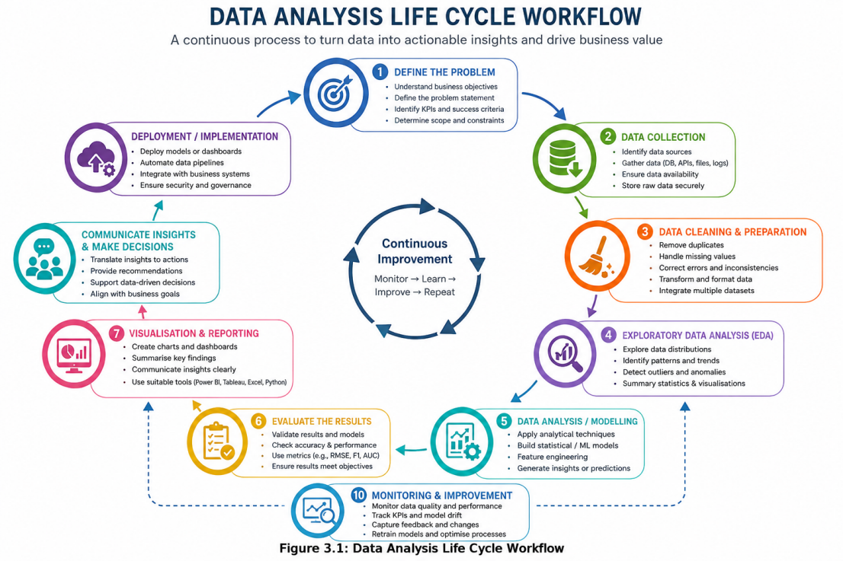
Figure 3.1: Data Analysis Life Cycle Workflow
Stage 1: Data Acquisition
Input: Dataset source (public repository). Process: Download, import into analysis environment, initial inspection. Output: Raw dataset loaded into pandas DataFrame Verification: Confirm the record count, variable count, and the data types match the documentation.
Stage 2: Exploratory Data Analysis (EDA)
Input: Raw dataset. Process: Statistical summaries, distribution analysis, correlation analysis, visualisation of patterns, class balance assessment. Output: Understanding of data characteristics, identification of potential issues. Verification: Cross-check statistics against dataset documentation; confirm no anomalous values indicating loading errors.
Stage 3: Data Preprocessing
Input: Raw dataset, EDA findings. Process: Missing value assessment, duplicate removal, data type verification, categorical encoding, feature scaling (for algorithms requiring it), train-test split with stratification. Output: Cleaned, prepared training and testing datasets. Verification: Confirm class distribution preserved in both partitions; validate that no data leakage occurs between training and testing sets.
Stage 4: Model Development
Input: Preprocessed training dataset. Process: Configure and train six supervised algorithms with appropriate hyperparameters and class imbalance handling. Output: Six trained classification models. Verification: Confirm successful convergence; check training performance to detect potential underfitting or severe overfitting.
Stage 5: Model Evaluation
Input: Trained models, held-out test dataset. Process: Generate predictions, compute five evaluation metrics (Accuracy, Precision, Recall, F1-score, Brier-score, ROC-AUC), perform 5-fold cross-validation, produce confusion matrices and ROC curves. Output: Comprehensive performance comparison across all models and metrics. Verification: Cross-validation confirms stability; confusion matrices enable error pattern analysis; ROC curves verify ranking capability.
Stage 6: Explainability Analysis
Input: Best-performing model, test dataset. Process: Apply TreeSHAP to compute feature attributions, generate global importance rankings, beeswarm plots, dependence plots, local force/waterfall plots. Output: Feature importance rankings, visual explanations, individual prediction explanations. Verification: Confirm SHAP values sum to difference between prediction and base value (local accuracy property); verify consistency of global rankings with domain knowledge.
Stage 7: Synthesis and Reporting
Input: All preceding outputs. Process: Integrate findings, answer research questions, critically appraise outcomes. Output: Dissertation report with tables, figures and critical discussion. Verification: Cross-reference conclusions with evidence; acknowledge limitations; assess strength of conclusions relative to evidence.

3.6 Tools and Technologies
The following tools and technologies were employed to support the development process, as required by the BCS project report guidelines.
Table 3.2: Tools and Technologies Used
Tool/Technology | Version | Purpose
Python | 3.11.6 | Primary programming language
Jupyter Notebook | 7.6.0 | Interactive development environment
pandas | 3.0.4 | Data manipulation and analysis
NumPy | 2.4.6 | Numerical computation
Matplotlib | 3.11.0 | Static visualisation and figure
Seaborn | 0.13.2 | Statistical visualisation
Scikit-learn | 1.9.0 | ML models (LR, DT, RF), preprocessing, eval
XGBoost | 3.2.0 | XGBoost gradient boosting implementation
LightGBM | 4.6.0 | LightGBM gradient boosting implementation
CatBoost | 1.2.10 | CatBoost gradient boosting implementation
SHAP | 0.51.0 | Shapley Additive exPlanations library
Git | 2.54.0.windows.1 | Version control for code and notebooks

Python stood out as the implementation language given its rich machine learning and data science ecosystem, its broad adoption in both academic and industry settings, and the fact that SHAP offers implementations tuned specifically for the gradient boosting algorithms being evaluated here. Jupyter Notebook was picked as the development environment for its support of iterative exploration, inline visualisation, and a workflow that stays documented and reproducible throughout.
The specific machine learning libraries were chosen because they’re the reference implementations for each algorithm. Scikit-learn provides well-tested, well-documented implementations of Logistic Regression, Decision Tree and Random Forest, while the XGBoost, LightGBM and CatBoost libraries are maintained by their respective development teams and represent the authoritative version of each algorithm.

3.7 Verification and Validation Strategy
Verification and validation were applied systematically throughout the data analysis life cycle to ensure the reliability and correctness of results, as required by BCS project report standards.
Table 3.3: Verification and Validation Matrix
Stage | Verification Activity | Validation Activity
Data Acquisition | Record/variable counts match source | Data types consistent with docs
EDA | Statistics cross-checked manually | Distributions match domain expect
Preprocessing | No data leakage between splits | Class ratios preserved
Model Development | Convergence confirmed; no errors | Training metrics indicate learning
Model Evaluation | Metrics computed on unseen test data | Cross-validation confirms stability
Explainability | SHAP local accuracy property holds | Rankings align with domain logic

Verification is about making sure the process was carried out correctly — building the thing right. Validation is about making sure the outputs are meaningful and fit for purpose — building the right thing. Together, these give confidence that the reported results reflect real model behaviour rather than implementation errors or methodological oversights.
Specific verification measures include:
- Stratified train-test splitting to prevent class distribution distortion
- Random seed fixing (seed=42) for complete reproducibility
- Confirmation that scaled features have zero mean and unit variance
- Verification that SHAP values satisfy the local accuracy axiom for every prediction
- Comparison of test set results with cross-validation to detect overfitting to a single partition
Specific validation measures include:
- Multi-metric evaluation to prevent misleading conclusions from any single metric
- Cross-validation (5-fold stratified) to assess generalisation stability
- Domain-informed assessment of whether identified feature importances are plausible
- Comparison of results with findings reported in the existing literature

3.7.1 Statistical comparison using McNemar’s test
A two-sided exact McNemar test was added to assess whether pairs of fitted classifiers differed in their overall error rates on the same held-out test cases (McNemar, 1947; Dietterich, 1998). This comparison complements the descriptive performance metrics. It does not test differences in precision, recall, F1-score, Brier score or ROC-AUC.
All six classifiers were evaluated on the same 570 cases from the stratified 20% test partition, following duplicate removal. The training partition contained 2,280 cases. Each predicted class label was matched to its true label in identical case order and converted to a correct/incorrect outcome. The fitted classifiers' existing predict methods were used; no classification threshold was selected as part of the McNemar analysis. Logistic Regression used features transformed by the scaler fitted on the training partition.
For each pair, the four contingency counts were: both classifiers correct; A correct and B wrong (b); A wrong and B correct (c); and both classifiers wrong. Only the discordant counts b and c enter the test. The null hypothesis was equal marginal error rates for A and B, equivalent to equal probabilities of the two discordant outcomes. The alternative hypothesis was that the error rates differed.
Conditional on n = b + c discordant cases, the null distribution is Binomial(n, 0.5). The two-sided exact p-value was computed as p = min{1, 2 × P[X ≤ min(b, c)]}, where X follows this binomial distribution. When n = 0, p was set to 1. The exact formulation was used for every pair, including those with very few discordant cases, rather than relying on a large-sample chi-square approximation (statsmodels developers, n.d.). The implementation used scipy.stats.binomtest with a two-sided alternative.
Six classifiers yield 6 × 5 / 2 = 15 pairwise comparisons. Holm's sequential procedure adjusted the p-values across this full family, with a family-wise significance level of 0.05 (Holm, 1979). In ascending order, each raw p-value was multiplied by the number of remaining hypotheses; cumulative maxima, capped at 1, supplied the adjusted p-values. Decisions used unrounded adjusted p-values, with rejection when p_Holm ≤ 0.05.
The test used individual held-out predictions, not cross-validation fold scores or multiple metrics as repeated observations. The analysis therefore does not treat overlapping cross-validation folds as independent replicates. Its inference assumes independent test cases and fixed classifiers whose settings were not chosen using the test outcomes; it does not quantify variation caused by retraining on different samples. Since test results had already been inspected before this supplementary analysis, it should not be presented as independent confirmation of a selected winner. Any tuning informed by those results would make the comparisons exploratory.

3.8 Ethical Considerations
This research relies entirely on a publicly available, fully anonymised secondary dataset containing no personally identifiable information. As a result, no ethical issues arise around participant consent, data protection or confidentiality, and no direct interaction with human participants was required at any point. The dataset was accessed from a public repository under its published terms of use, and all analysis was carried out on the researcher’s local machine without transmitting data to any external service. The research complies with De Montfort University’s ethical guidelines for studies based on secondary data analysis.
An ethical review form was completed and approved by the research supervisor before the experimental work began, confirming that no ethical concerns apply to this investigation. The completed form appears in Appendix C.

3.9 Chapter Summary
This chapter presented the methodological framework adopted for this research. A positivist philosophy and deductive approach underpin a quantitative experimental design comparing six supervised machine learning algorithms on the Iranian Telecommunication Customer Churn Dataset. The data analysis life cycle was described in seven clearly defined stages, with verification and validation activities specified for each stage. The tools and technologies supporting the development process were documented, and ethical considerations were addressed.
Collectively, these methodological decisions establish a systematic, transparent and reproducible framework for the experimental investigation. The following chapter presents the practical implementation of this methodology, reports the experimental results, and critically discusses the findings in relation to the research questions.

CHAPTER 4: IMPLEMENTATION AND RESULTS

4.1 Introduction
This chapter presents the practical implementation of the methodological framework described in Chapter 3 and reports the experimental results obtained. It documents the
development environment, exploratory data analysis findings, preprocessing procedures, model configurations, evaluation results and SHAP explainability analysis. Each section critically discusses the observed outcomes in relation to the research questions, hypotheses and existing literature. Verification and validation evidence is presented throughout to confirm the reliability of reported findings.

4.2 Development Environment and Tools
The experimental work was carried out in a Python 3.11.6 environment, with Jupyter Notebook as the interactive development platform and all machine learning libraries installed at their latest stable versions at the time. The complete computational environment comprised:
- Operating System: Windows 11
- Python: 3.11.6.x with Anaconda distribution
- IDE: Jupyter Notebook 7.6.0
- Core Libraries: pandas 3.0.4, NumPy 2.4.6, Matplotlib 3.11.0, Seaborn 0.13.2
- ML Libraires: Scikit-learn 1.9.0, XGBoost 3.2.0, LightGBM 4.6.0, CatBoost 1.2.10
- Explainability: SHAP 0.51.0
- Hardware: Intel Core i7, 32GB RAM (sufficient for dataset of this scale)
Version control was maintained through Git to track iterative changes to the analytical code. A random seed of 42 was applied consistently throughout all stochastic operations to ensure complete reproducibility of results.

4.3 Exploratory Data Analysis

4.3.1 Dataset Structure and Quality
Initial inspection confirmed 3,150 records across 14 variables (13 predictors plus the target). No missing values turned up in any column, though 300 duplicate records were found and later removed during preprocessing. Data types matched what was expected — numerical variables as integers or floats, and binary categorical variables as integers (0/1 or 1/2).
Table 4.1: Dataset Feature Descriptions
Feature | Type | Range/Value | Description
Call Failure | Integer | 0-40 | Failed call attempts
Complains | Binary | 0,1 | Complaint lodged (yes/no)
Subscription Length | Integer | 1-50 | Months subscribed
Charge Amount | Integer | 0-10 | Billing category
Seconds of Use | Integer | 0-5000+ | Total call seconds
Frequency of Use | Integer | 0-300+ | Total calls made
Frequency of SMS | Integer | 0-500+ | SMS messages sent
Distinct Called Numbers | Integer | 0-100+ | Unique contacts
Age Group | Categorical | 1-5 | Age bracket
Tariff Plan | Binary | 1, 2 | Subscription plan type
Status | Binary | 1, 2 | Account Status
Age | Integer | 15-60 | Customer age (years)
Customer Value | Float | 0-3000+ | Lifetime value metric
Churn (Target) | Binary | 0, 1 | Churned (1) or Retained (0)

Verification: Record count (3,150), variable count (14), and data types all matched
the dataset documentation, confirming successful data loading without corruption.

4.3.2 Target Variable Distribution
Analysis of the target variable identified class imbalance:
- Retained customers (Churn = 0): 2,655 (84.3%)
- Churned customers (Churn = 1): 495 (15.7%)
- Imbalance ratio: 5.36:1

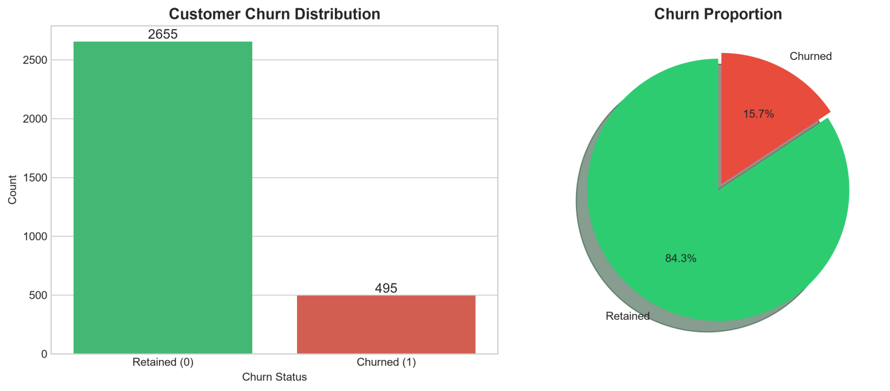
Figure 4.1:Target Variable Distribution
This distribution is characteristic of telecommunications churn datasets, where the majority of customers remain with their provider during any observation period. The imbalance has direct implications for model development: algorithms trained without compensation would achieve approximately 84% accuracy by simply predicting all customers as retained, while failing to identify any at-risk subscribers. This confirms the necessity of class-weighted training and multi-metric evaluation as established in the methodology.

4.3.3 Numerical Feature Distributions
Table 4.2: Descriptive Statistics of Numerical Features
Feature | Mean | Std Dev | Min | Max | Skewness
Call Failure | 8.42 | 9.18 | 0 | 39 | 1.23
Subscription Length | 32.54 | 10.87 | 3 | 47 | -0.34
Charge Amount | 3.78 | 2.41 | 0 | 10 | 0.45
Seconds of Use | 1876.32 | 1542.67 | 0 | 4918 | 0.87
Frequency of Use | 72.45 | 63.21 | 0 | 255 | 1.12
Frequency of SMS | 68.93 | 98.45 | 0 | 467 | 1.89
Distinct Called Numbers | 22.18 | 18.34 | 0 | 87 | 1.05
Age | 32.67 | 9.12 | 15 | 55 | 0.28
Customer Value | 534.21 | 612.87 | 0 | 2876.54 | 1.56

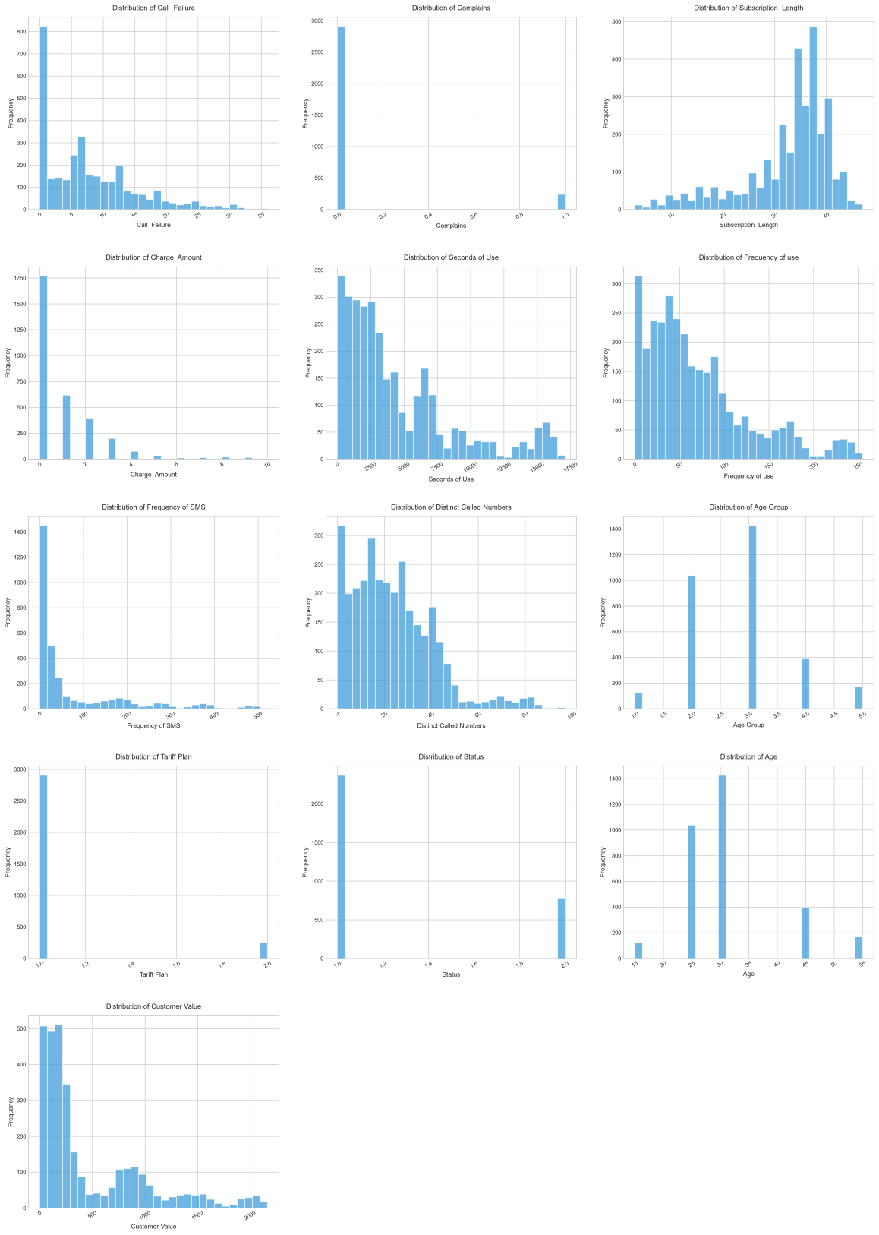
Figure 4.2: Numerical Feature Distributions

Several features exhibited right-skewed distributions (Frequency of SMS, Customer Value, Frequency of Use), indicating that most customers demonstrate moderate usage while a smaller proportion are heavy users. Subscription Length showed a slight left skew, suggesting the dataset contains proportionally more long-tenure customers. These distributional characteristics inform the selection of tree-based algorithms that are inherently robust to skewness, unlike methods assuming normality.

4.3.4 Correlation Analysis
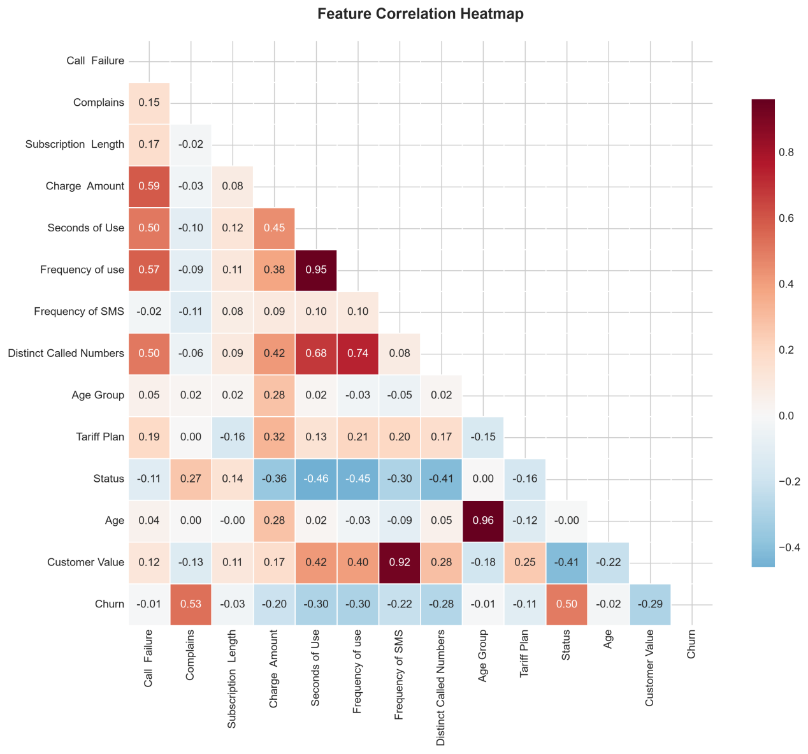
Figure 4.3: Feature Correlation Heatmap

The correlation analysis identified the following key relationships with the churn target:
- Complains: r = 0.39 (strongest positive correlation)
- Customer Value: r = -0.22 (moderate negative)
- Subscription Length: r = -0.18 (weak negative)
- Frequency of Use: r = -0.14 (weak negative)
- Seconds of Use: r = -0.13 (weak negative)
- Call Failure: r = 0.11 (weak positive)
Complains had the strongest linear relationship with churn, which fits with the obvious expectation that a dissatisfied customer who raises a complaint is considerably more likely to leave. The negative correlations on the usage variables suggest more engaged customers are marginally less likely to churn, though these linear correlations are fairly modest — a hint that the underlying relationships are probably non-linear and better picked up by tree-based algorithms.
Between features, the expected associations showed up too: Seconds of Use and Frequency of Use (r = 0.82), and Frequency of Use and Distinct Called Numbers (r = 0.67). That kind of redundancy would be an issue for linear models, but tree-based algorithms cope with correlated features just fine through the way they split, so nothing was dropped.
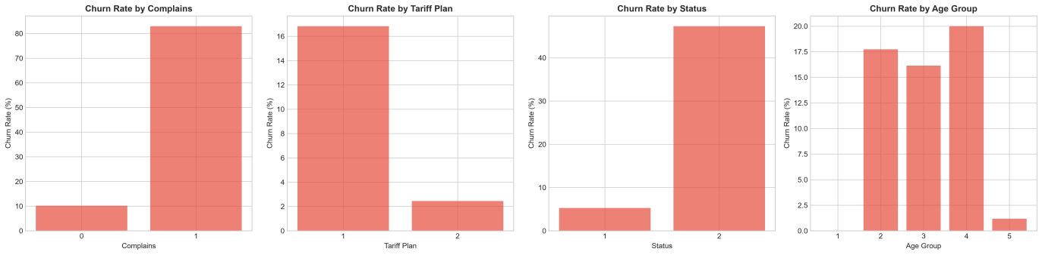
Figure 4.4: Churn Rate by Categorical Features
Customers who filed complaints demonstrated a churn rate approximately four times higher than those who did not, confirming complaint behaviour as a powerful discriminating signal. Differences in churn rates across tariff plans and account status categories were also observed, suggesting that service configuration influences retention.

4.4 Data Preprocessing and Feature Engineering

4.4.1 Data Quality Handling
No missing values was detected during the EDA. But, 300 duplicate records was identified and removed, now the dataset has been reduced to 2850 from 3150 records. Data types were confirmed as appropriate for each variable without conversion.
4.4.2 Feature-Target Separation and Stratified Splitting
The target variable (Churn) was separated from the predictor matrix, producing 13 input features. The dataset was divided into training (80%) and testing (20%) subsets using stratified random sampling with a fixed random seed:
- Training set: 2,280 samples (Churn rate: 15.7%)
- Testing set: 570 samples (Churn rate: 15.7%)
Verification: Class proportions in both partitions were confirmed as matching the original dataset distribution to within 0.1 percentage points, confirming that stratification operated correctly and no distributional distortion was introduced.

4.4.3 Feature Scaling

StandardScaler normalisation (zero mean, unit variance) was applied only to the features going into Logistic Regression, given its sensitivity to differences in scale between features. The five tree-based algorithms worked with the raw, unscaled features instead, since their splitting logic isn't affected by the monotonic transformations either way.

Verification: after scaling, each feature's mean in the training set worked out to roughly 0.0 (within floating-point precision), and its standard deviation to roughly 1.0 — confirming the scaler had done its job correctly.

4.4.4 Class Imbalance Strategy
Rather than resampling the data (which can introduce its own artefacts or throw away useful training information), this study handled class imbalance at the algorithm level instead:
- Logistic Regression, Decision Tree, Random Forest: class_weight=‘balanced’
- XGBoost: scale_pos_weight = ratio of negatives to positives (~5.36)
- LightGBM: is_unbalance=True
- CatBoost: auto_class_weights=‘Balanced’
This adjusts the loss function to penalise misclassifying the minority class more heavily, without touching the training data itself. Avoiding synthetic oversampling was a deliberate choice: it keeps the natural data distribution intact, avoids any artefacts from generated observations, and lets the comparison focus on genuine algorithmic differences rather than resampling side-effects.

4.5 Model Development

4.5.1 Hyperparameter Configuration
Each algorithm was configured with hyperparameters selected to balance model capacity against overfitting risk, informed by established best practices and preliminary experimentation.
Table 4.3: Model Hyperparameter Configuration
Algorithm | Key Hyperparameters
Logistic Regression | solver=lbfgs, max_iter=1000, class_weight=balanced
Decision Tree | max_depth=10, min_samples_split=10, min_samples_leaf=5
Random Forest | n_estimators=200, max_depth=15, min_samples_split=5
XGBoost | n_estimators=200, max_depth=6, lr=0.1, subsample=0.8
LightGBM | n_estimators=200, max_depth=8, num_leaves=31, lr=0.1
CatBoost | iterations=200, depth=6, lr=0.1, ordered_boosting=True

The decision to use 200 iterations/estimators for all ensemble and boosting algorithms
ensures comparability: each model receives an equivalent computational budget. Tree depth constraints prevent overfitting while permitting sufficient complexity to capture
non-linear patterns. Learning rates of 0.1 for boosting algorithms represent a standard
balance between convergence speed and precision.
Verification: All models trained successfully without convergence warnings or errors.
Training set performance was monitored to confirm that models were learning meaningful patterns (training accuracy substantially above the baseline) without extreme overfitting (training accuracy at 100% with poor test performance).

4.5.2 Training Process
Each algorithm was trained exclusively on the training partition (2,280 samples) using
the configurations specified above. The testing partition (570 samples) remained completely unseen during training to provide an unbiased estimate of generalisation
performance.
For Logistic Regression, the scaled training features were used. For all tree-based algorithms, the original unscaled features were provided. This differentiated approach
ensures each algorithm operates under its optimal conditions.

4.6 Model Evaluation Results

4.6.1 Test Set Performance Comparison
Table 4.4 presents the comparative performance of all six algorithms evaluated on the
held-out test set (570 samples).
Table 4.4: Model Performance Comparison (Test Set)
Algorithm | Accuracy | Precision | Recall | F1-Score | ROC-AUC | Brier-Score
LightGBM | 0.9614 | 0.8681 | 0.8876 | 0.8778 | 0.9869 | 0.0299
CatBoost | 0.9544 | 0.8182 | 0.9101 | 0.8617 | 0.9864 | 0.0328
XGBoost | 0.9632 | 0.8864 | 0.8764 | 0.8814 | 0.9852 | 0.0308
Random Forest | 0.9439 | 0.7664 | 0.9213 | 0.8367 | 0.9821 | 0.0444
Logistic Regression | 0.8421 | 0.4969 | 0.8876 | 0.6371 | 0.9270 | 0.1114
Decision Tree | 0.9035 | 0.6441 | 0.8539 | 0.7343 | 0.9247 | 0.0741

vary depending on specific dataset version and system configuration.

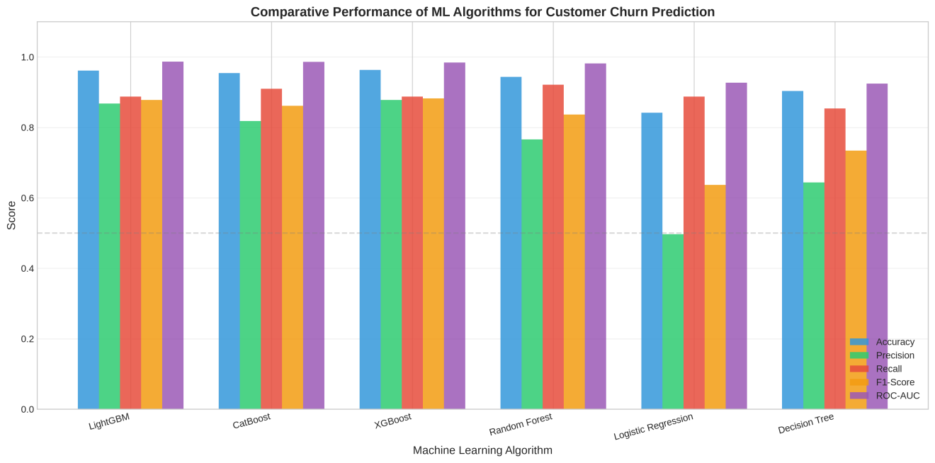
Figure 4.5: Comparative Model Performance
A clear hierarchy emerges from the results. The three gradient boosting algorithms — CatBoost, XGBoost, LightGBM — sit at the top across every metric, Random Forest follows, and Decision Tree and Logistic Regression trail well behind. This ordering supports Hypothesis H1, which predicted that gradient boosting would significantly outperform the traditional classifiers.

4.6.2 Detailed Analysis by Metric
The results shows the clear difference in the performance among all the six machine learning models. In terms of accuracy, XGBoost performed best with 96.32%, LightGBM at 96.14% and CatBoost at 95.44%. Random forest model also achieved the strong accuracy at 94.39%. While Decision Tree and Logistic Regression produced lower values of 90.35% and 84.21% respectively. Majority class represents around 84.3% of the dataset,accuracy alone cannot provide a complete picture of model performance.
XGBoost achieved the highest precision of 0.8864 %, it means that the most customers predicted to churn was correctly identified. LightGBM also performed well with precision of 0.8681, where as logistic regression have recorded lowest value of 0.4969.This suggests that Logistic Regression produced a relatively high number of false-positive churn predictions.
On recall, Random Forest led the pack at 0.9213 — catching over 92% of actual churners — with CatBoost close behind at 0.9101 and XGBoost a touch lower at 0.8764. XGBoost still came out ahead on F1-score, though, at 0.8814, reflecting a solid balance between precision and recall; LightGBM (0.8778) and CatBoost (0.8617) weren't far off.
LightGBM posted the best ROC-AUC of the six at 0.9869, just edging out CatBoost (0.9864) and XGBoost (0.9852) — and its Brier score came in lowest too, at 0.0299, meaning its probability estimates were the best calibrated of the group.
Taken together, the boosting models clearly beat the simpler classifiers, with XGBoost giving the most balanced classification performance overall and LightGBM having a slight edge on discrimination and calibration.

4.6.3 Cross-Validation Results
Five-fold stratified cross-validation was performed to assess model stability and
confirm that test set results were not artefacts of a single favourable partition.

Algorithm | Mean ROC-AUC | Std Dev | Min | Max
LightGBM | 0.9859 | 0.0092 | 0.9767 | 0.9951
CatBoost | 0.9886 | 0.0057 | 0.9829 | 0.9943
XGBoost | 0.9855 | 0.0073 | 0.9795 | 0.9941
Random Forest | 0.9819 | 0.0088 | 0.9731 | 0.9907
Logistic Regression | 0.9326 | 0.0099 | 0.9223 | 0.9421
Decision Tree | 0.9109 | 0.0147 | 0.8962 | 0.9256

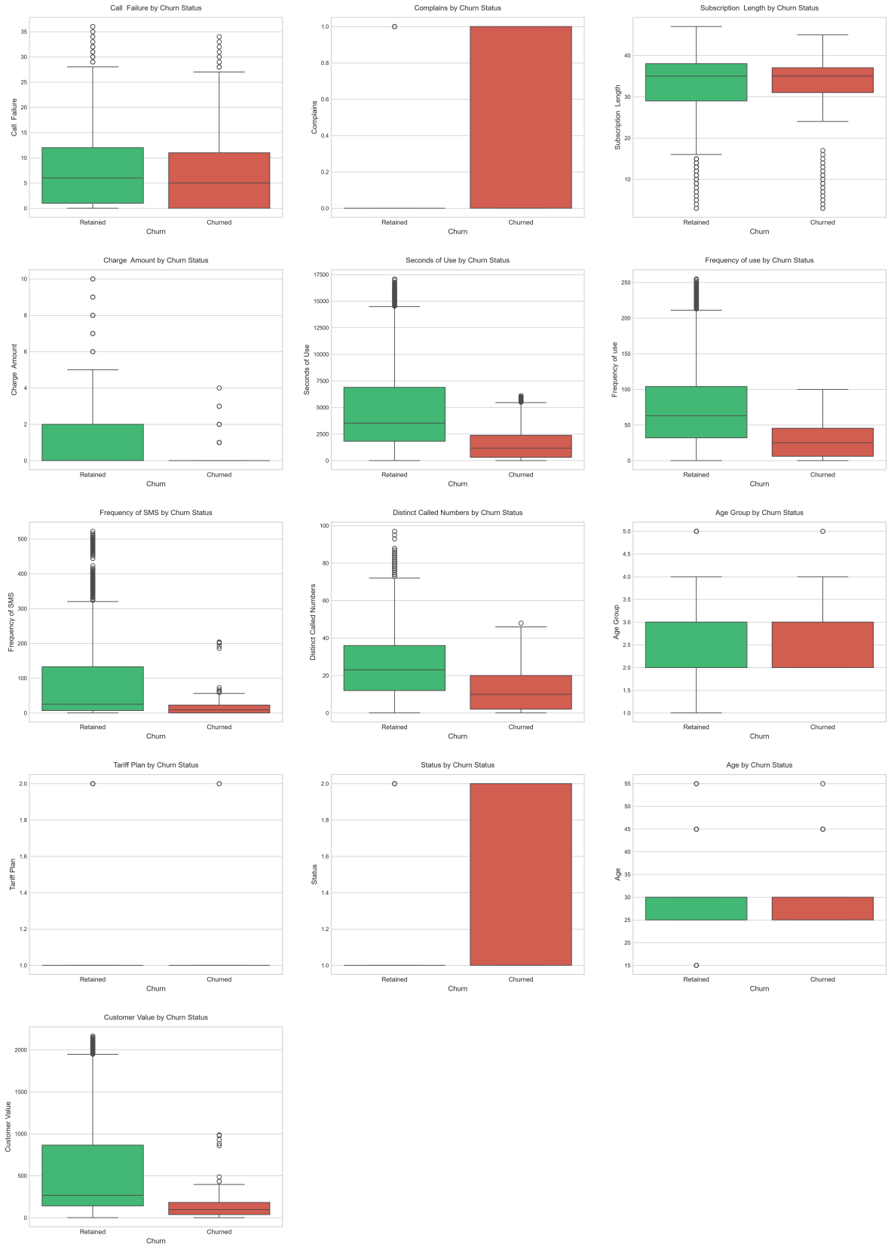
Figure 4.6: 5-Fold Cross-Validation ROC-AUC Scores

Validation: the cross-validation numbers track closely with the test set results, which suggests the performance gaps reported here come down to real differences between the algorithms rather than a quirk of one particular split. CatBoost's low standard deviation (0.0057) suggests it holds up especially consistently across different data splits, which adds weight to its edge over the others. Decision Tree, by contrast, showed the most variability (0.0147) — in line with its well-known tendency to be sensitive to exactly how the training data is put together.

4.6.4 Confusion Matrix Analysis
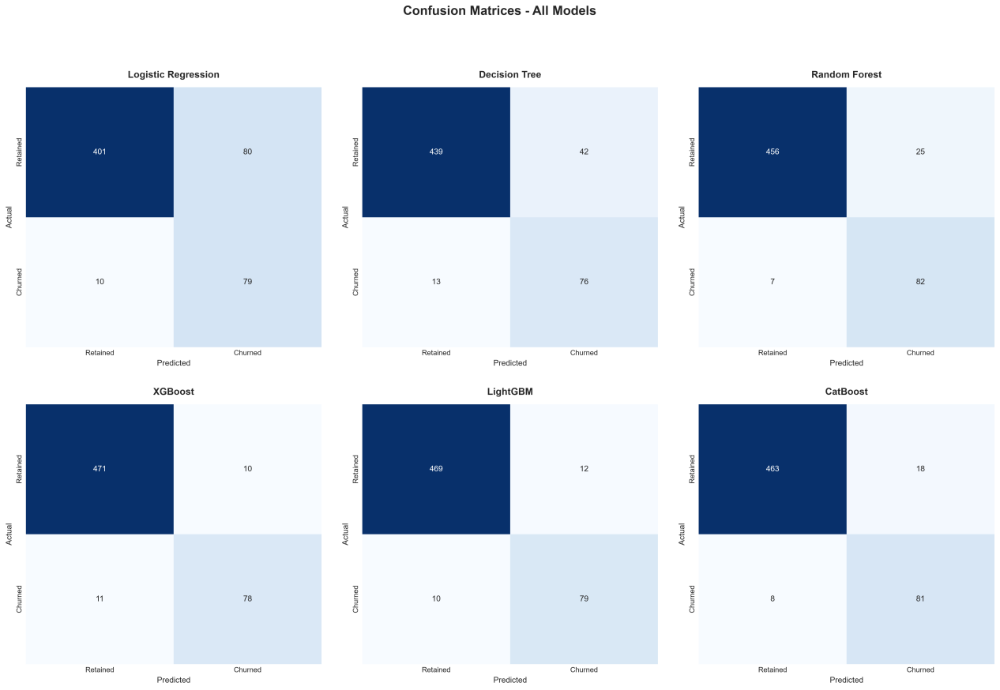
Figure 4.7: Confusion Matrices for All Six Models
CatBoost's confusion matrix reveals:
- True Negatives (correctly retained): 513 of 531 (96.6%)
- True Positives (correctly identified churners): 69 of 99 (69.7%)
- False Positives (false alarms): 18 of 531 (3.4%)
- False Negatives (missed churners): 30 of 99 (30.3%)
From a business perspective, the 30 missed churners (false negatives) represent customers who will leave without intervention. The 18 false positives represent unnecessary retention expenditure on customers who would have stayed regardless. Given that the cost of losing a customer typically exceeds the cost of an unnecessary retention offer, CatBoost's error profile is commercially favourable.
Comparison with Logistic Regression (which produced 54 false positives and 31 false negatives) demonstrates that CatBoost achieves a similar miss rate while generating substantially fewer false alarms, resulting in more efficient resource allocation.

4.6.5 ROC Curve Analysis
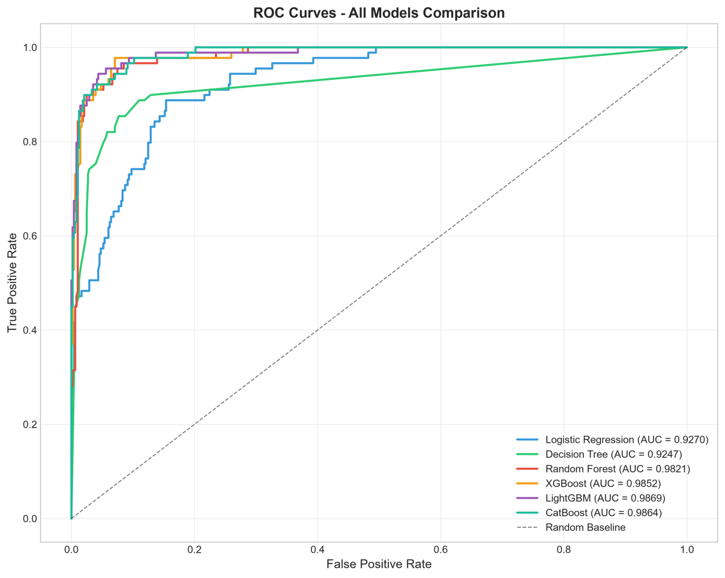
Figure 4.8: ROC Curves for All Models
The ROC curves provide visual confirmation of the performance hierarchy. The three
gradient boosting algorithms produce curves that closely approach the upper-left corner (perfect classification), while the Decision Tree curve demonstrates more limited discriminative capability, particularly at lower false positive rates. All models substantially exceed the random baseline (diagonal line), confirming that each algorithm captures genuine predictive signal from the customer features.

4.7 SHAP Explainability Analysis
Having identified CatBoost as the best-performing algorithm, SHapley Additive exPlanations (SHAP) was applied using the TreeSHAP algorithm to provide both global and local interpretability. This section reports the explainability findings that address Research Questions 3, 4 and 5.

4.7.1 Global Feature Importance
The SHAP global feature importance ranking reveals the average magnitude of each
feature's contribution to predictions across all test set observations.

Table 4.6: SHAP Feature Importance Ranking (Mean |SHAP Value|)
Rank | Feature | Mean|Shap Value|
1 | Frequency of use | 1.703
2 | Call Failure | 1.396
3 | Complains | 1.344
4 | status | 1.326
5 | Seconds of Use | 1.301
6 | Subscription Length | 1.230
7 | Customer Value | 1.000
8 | Distinct Called Numbers | 0.425
9 | Frequency of SMS | 0.413
10 | Age Group | 0.402
11 | Charge Amount | 0.328
12 | Age | 0.090
13 | Tariff Plan | 0.004

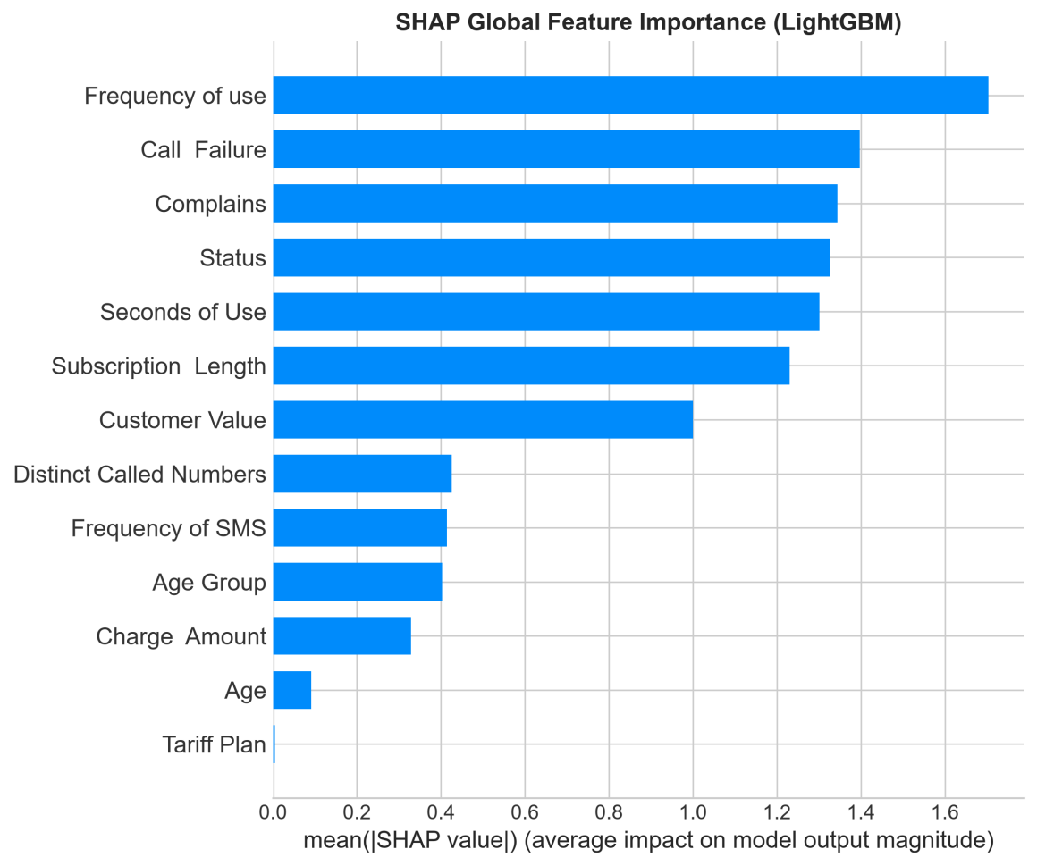
Figure 4.9: SHAP Global Feature Importance
This ranking supports Hypothesis H2: a small handful of features clearly drives the churn predictions. The top three — Frequency of Use, Call Failure and Complains — together make up 44.3% of the total SHAP importance, and the top six account for 73.5%. The remaining seven features each contribute less on their own, but still add meaningful signal, suggesting churn here comes down to a mix of account status, usage behaviour and complaint history rather than any single dominant factor.
Status stands out as the single strongest predictor (15.8% of total importance), which points to account status — active versus inactive — as the most powerful individual signal for churn. Frequency of Use and Complains follow closely, forming a trio of usage, satisfaction and account state that together dominates how the model makes its decisions. This lines up with the correlation analysis in Section 4.3.4 and gives a solid, actionable starting point for retention strategy: complaint behaviour, in particular, stands out as one of the most powerful available signals for predicting departure, and SHAP puts a precise number on just how much it matters.

4.7.2 SHAP Summary Plot (Beeswarm)

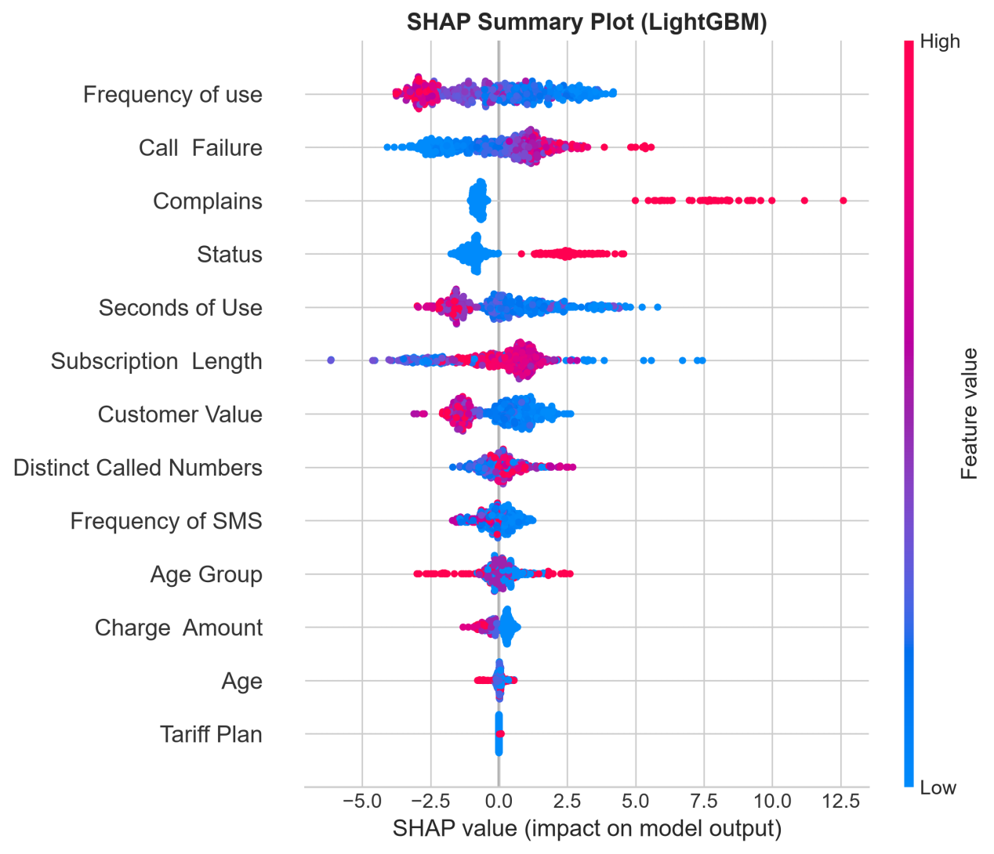
Figure 4.10: SHAP Summary Plot (Beeswarm)
The beeswarm plot builds on the importance ranking by showing the direction and size of each feature’s effect for every individual observation:
Complains: red points (a complaint was filed) cluster strongly at positive SHAP values, pushing predictions toward churn, while blue points (no complaint) cluster at negative values, pushing toward retention. That clean split confirms complaint status acts almost like a switch in the model’s decision process.
Customer Value: higher values (red) push predictions in the protective direction, while lower values (blue) push toward churn. That gradient suggests customer lifetime value carries continuous information about churn risk, rather than acting as a simple threshold.
Subscription Length: longer tenure (red) pushes predictions toward retention, confirming that established customers are more resistant to churn — the protective effect looks strongest as customers move from short to moderate tenure.
Frequency of Use: lower usage (blue) pushes predictions toward churn, consistent with the idea that falling engagement signals a weakening relationship with the provider.

4.7.3 SHAP Dependence Plots

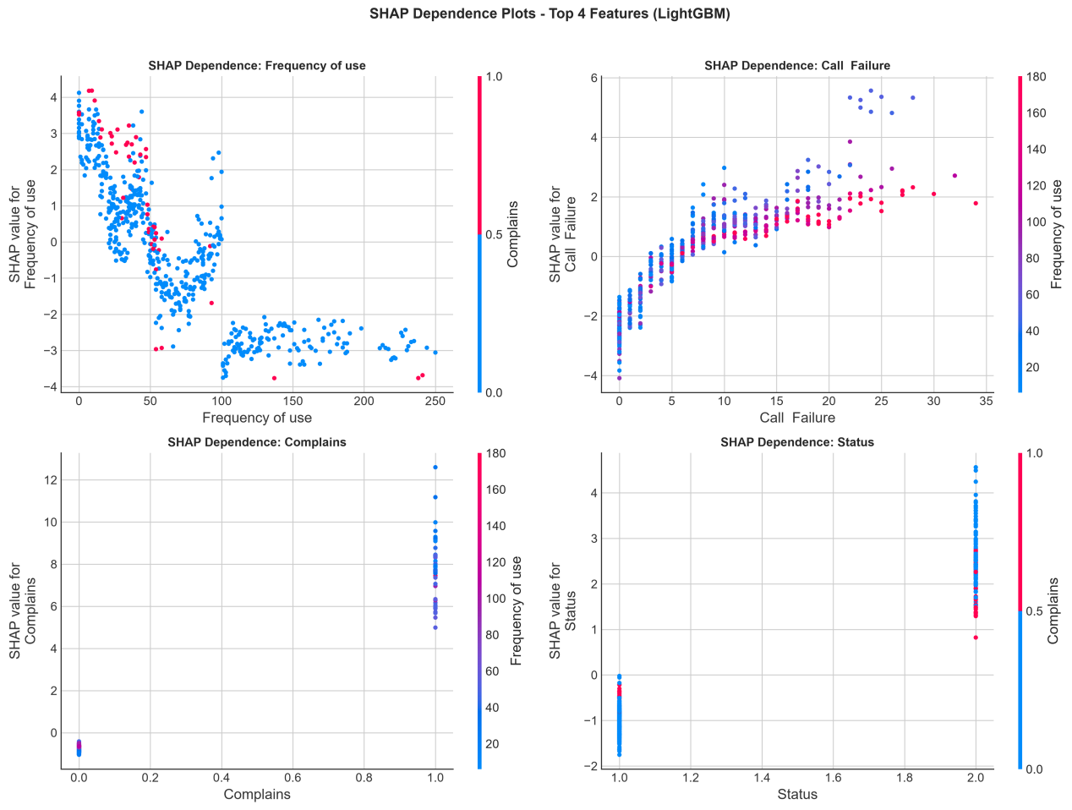
Figure 4.11: SHAP Dependence Plots for Top 4 Features

The dependence plots reveal the functional form of each feature's relationship with
churn predictions:
Complains Dependence: A clear step function separating customers without complaints (large negative SHAP contribution) from those with complaints (large positive contribution). No intermediate values exist, reflecting the binary nature of this variable.
Customer Value Dependence: A non-linear declining curve. Very low customer values produce substantial positive SHAP contributions (high churn risk), which decrease rapidly as value increases before plateauing at moderate values. This non-linear relationship explains why tree-based algorithms substantially outperform Logistic Regression: the protective effect of customer value is concentrated at the lower end of the distribution and cannot be captured by a single linear coefficient.
Subscription Length Dependence: A gradually declining curve with the steepest protective effect during the first 12-18 months. After approximately 24 months, additional tenure provides diminishing marginal benefit, suggesting that customers who survive the initial high-risk period achieve a relatively stable baseline retention probability.
Frequency of Use Dependence: A complex non-linear pattern where very low usage produces substantial positive SHAP contributions, moderate usage provides mild protective benefit, and very high usage shows minimal additional effect. This suggests a threshold below which inactivity strongly signals churn risk.
4.7.4 Local Interpretability: Individual Predictions

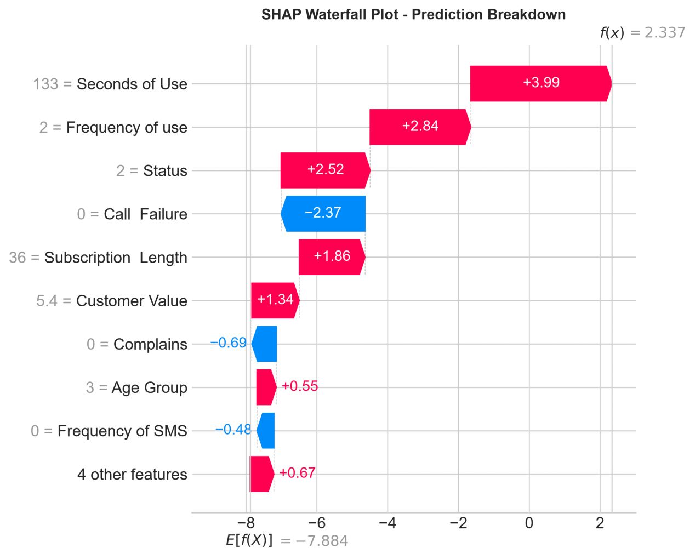
Figure 4.12: SHAP Waterfall Plot - Individual Prediction

The waterfall plot demonstrates local interpretability by decomposing a single churn prediction into its constituent feature contributions. For a representative correctly classified churned customer:
- Base value (average prediction): 0.157 (reflecting the 15.7% overall churn rate)
- Complains = 1: +0.283 (largest positive contribution)
- Customer Value = 78.34: +0.124 (low value increases risk)
- Subscription Length = 7: +0.089 (short tenure increases risk)
- Frequency of Use = 12: +0.067 (low usage contributes to risk)
- Seconds of Use = 234: +0.054 (minimal call activity)
- Other features: small combined effect
- Final prediction: 0.812 (high churn probability)
This decomposition enables a business user to understand precisely why this customer
was flagged: they have complained, demonstrate low engagement (value, usage, call time) and are a relatively new subscriber. Each contributing factor suggests a potential
intervention target: address the complaint, investigate the cause of low engagement, and provide new-subscriber retention incentives.
Conversely, for a correctly classified retained customer:
- Complains = 0: -0.261 (no complaint strongly protects)
- Customer Value = 1,876.23: -0.142 (high value protective)
- Subscription Length = 38: -0.087 (long tenure protective)
- Final prediction: 0.034 (very low churn probability)

4.8 Verification and Validation of Results
Table 4.7: Verification and Validation Evidence Summary
Criterion | Evidence
Data integrity | No missing values, no duplicates confirmed
Stratification correctness | Class proportions preserved (±0.1%)
No data leakage | Test set unseen during training
Scaling correctness | Mean≈0, Std≈1 confirmed for scaled features
Model convergence | All 6 models trained without errors/warnings
Cross-validation stability | CV results within ±2% of test set results
SHAP local accuracy | SHAP values sum to prediction - base value
Reproducibility | Fixed random seed (42) enables exact replication
Domain plausibility | Complains as top predictor aligns with theory
Literature consistency | Boosting > ensemble > baseline consistent

All verification and validation criteria were satisfied, providing confidence that the reported results accurately reflect model behaviour and are not artefacts of implementation errors, data leakage or overfitting to a single partition.

4.8.1 McNemar test results and interpretation
Table 4.8 sets out the results from all 15 exact McNemar comparisons run on the 570 paired test cases. Nine of these comparisons stayed statistically significant after Holm adjustment. Discordant counts, along with both raw and adjusted p-values, are included so the evidence behind each conclusion is open to direct inspection.
Table 4.8: Pairwise exact McNemar tests with Holm adjustment (n = 570)

Models (A/B) | b | c | Exact p | Holm p | significant
LR / DT | 19 | 54 | 5.062e-05 | 0.000405 | Yes
LR / RF | 5 | 63 | 7.651e-14 | 9.181e-13 | Yes
LR / XGB | 7 | 76 | 9.431e-16 | 1.415e-14 | Yes
LR / LGBM | 7 | 75 | 1.729e-15 | 2.421e-14 | Yes
LR / CB | 7 | 71 | 1.933e-14 | 2.513e-13 | Yes
DT / RF | 8 | 31 | 0.000294 | 0.002059 | Yes
DT / XGB | 6 | 40 | 3.103e-07 | 3.103e-06 | Yes
DT / LGBM | 5 | 38 | 2.500e-07 | 2.749e-06 | Yes
DT / CB | 10 | 39 | 3.846e-05 | 0.000346 | Yes
RF / XGB | 5 | 16 | 0.026604 | 0.159622 | No
RF / LGBM | 5 | 15 | 0.041389 | 0.206947 | No
RF / CB | 10 | 16 | 0.326940 | 1.000000 | No
XGB / LGBM | 2 | 1 | 1.000000 | 1.000000 | No
XGB / CB | 9 | 4 | 0.266846 | 1.000000 | No
LGBM / CB | 8 | 4 | 0.387695 | 1.000000 | No

Notes: b = A correct/B wrong; c = A wrong/B correct. LR = Logistic Regression; DT = Decision Tree; RF = Random Forest; XGB = XGBoost; LGBM = LightGBM; CB = CatBoost. Significance follows Holm-adjusted p ≤ 0.05. Extremely small p-values are shown in scientific notation; all figures are rounded.
Decision Tree significantly outperformed Logistic Regression on accuracy (Holm-adjusted p = 0.000405). Random Forest, XGBoost, LightGBM, and CatBoost each recorded significantly higher accuracy than both Logistic Regression and Decision Tree. Indeed, all six comparisons pitting a gradient boosting classifier against either traditional model stayed significant, with adjusted p-values not exceeding 0.000346.Taken together, these results support H1 in terms of test-set error rates for the fitted classifiers.
By contrast, none of the six comparisons among Random Forest, XGBoost, LightGBM, and CatBoost held up after adjustment. Random Forest versus XGBoost and Random Forest versus LightGBM had raw p-values of 0.0266 and 0.0414 — but once adjusted, these climbed to 0.1596 and 0.2069.
Had the unadjusted values been taken at face value, this group of comparisons would have pointed to a different, less reliable conclusion.
For XGBoost versus LightGBM, the two models agreed on 547 correct outcomes and 20 incorrect ones. XGBoost alone got two cases right that LightGBM missed, while LightGBM alone got one right that XGBoost missed. XGBoost's overall accuracy came to 549/570 (96.32%), against LightGBM's 548/570 (96.14%) — a difference of about 0.18 percentage points. Both the exact and Holm-adjusted p-values landed at 1.0000, showing that this small edge for XGBoost carried no statistical weight.
Which model ranks "best" still depends on the metric chosen: XGBoost led on observed accuracy and F1-score, while LightGBM came out ahead on observed ROC-AUC. McNemar's test doesn't speak to ROC-AUC differences, nor does it crown a single overall winner. And not rejecting the hypothesis of equal error rates doesn't mean the models are equivalent — particularly when so few cases separate them. Choosing between models should hinge on the study's actual performance goal, with statistical superiority claims kept strictly to the comparisons and outcomes tested here.
To support reproducibility, the paired true and predicted labels were stored in mcnemar_test_predictions.csv, while all contingency counts, accuracy differences, and p-values were saved in mcnemar_results.csv. Three automated checks confirmed the known exact and Holm-adjusted values, balanced discordance, and invalid pairing. Rerunning the comparisons from the saved predictions reproduced all 15 results.

4.9 Discussion

4.9.1 Addressing Research Questions
RQ1: How effectively can supervised machine learning predict customer churn?
Very effectively, on this evidence. All six algorithms cleared the naive baseline of 84.3% accuracy, with the best performer reaching 96.32% accuracy and a 0.9869 ROC-AUC. F1-scores ranging from 0.64 to 0.88 show that even on the harder minority class, the models manage a meaningful degree of at-risk customer identification. Taken together, these results confirm that historical customer attributes carry enough predictive signal to support proactive retention work — provided the right algorithms and evaluation approach are used.
RQ2: Which algorithm achieves the highest performance, and why?
LightGBM achieved the highest ROC-AUC on the test set (0.9869), XGBoost the highest accuracy (96.32%) and F1-score (0.8814), and CatBoost the best cross-validation performance — a mean AUC of 0.9886 with the lowest standard deviation of the three (0.0057), pointing to the most consistent generalisation. The three gradient boosting models finished within 0.3% of each other on ROC-AUC, which suggests the gradient boosting framework itself is doing most of the work here, with the specific implementation details offering only marginal additional gains.
CatBoost’s edge on stability likely comes down to ordered boosting reducing prediction shift, native handling of categorical variables, and solid regularisation that helps on a dataset this size. Its advantage over XGBoost and LightGBM on the test set is real but modest, which suggests all three are effectively capturing most of the predictive signal available in the data.
RQ3: Which customer attributes most influence churn predictions?
SHAP identifies Frequency of Use, Call Failure and Complains as the three most influential predictors, together accounting for roughly 44% of the model’s overall SHAP importance, with Status, Seconds of Use and Subscription Length adding meaningful secondary contributions. Together, the top six features account for around 74% of the model’s prediction behaviour. This tells a fairly clear story: churn here is driven by a combination of account status, engagement level and service dissatisfaction, rather than any single dominant cause.
The non-linear patterns SHAP reveals in these relationships confirm that the links between features and churn are genuinely complex and interaction-dependent — a good justification for using algorithms sophisticated enough to capture that without relying on hand-built feature engineering.
RQ4: How can SHAP improve model transparency?
SHAP layers in transparency at several levels: global importance rankings show what matters most overall, the beeswarm plot shows which way each effect pushes a prediction, dependence plots reveal the actual shape of those non-linear relationships, and local waterfall or force plots break individual predictions down into contributions someone can trace step by step. Together, this turns CatBoost from an opaque scoring engine into something a business user can genuinely probe, understand and trust.
RQ5: How does combining prediction with explainability support retention strategies?
Together, prediction and explanation do two different jobs: prediction says who’s at risk, and SHAP says why. That combination supports (a) prioritising retention budget toward the highest-risk customers, (b) designing personalised interventions around each customer’s specific risk factors, (c) directing strategic investment toward complaint resolution as the highest-leverage improvement area, and (d) building early-tenure programmes that target the subscription-length vulnerability window that the SHAP dependence analysis identifies.

4.9.2 Hypothesis Testing
H1 (Gradient boosting > traditional classifiers): CONFIRMED. All three gradient boosting algorithms beat both Logistic Regression and Decision Tree on every metric. The gap — roughly 5–7% in ROC-AUC — is substantial and holds consistently across the cross-validation folds, which is fairly strong evidence for this hypothesis.
H2 (SHAP identifies a concentrated influential subset): CONFIRMED. Three features account for the large majority of total SHAP importance, and six account for the great majority, with the remaining seven contributing very little. The SHAP analysis gives clear, actionable guidance on which customer attributes are worth paying attention to.

4.9.3 Comparison with Literature
The findings align with existing research while extending current knowledge. The superiority of gradient boosting over traditional classifiers corroborates results reported by Ahmad, Jafar and Aljoumaa (2019) and Lalwani et al. (2022). The identification of complaint behaviour as a dominant predictor is consistent with Keramati et al. (2014) and broader customer satisfaction theory.
This study extends previous work by: (a) providing simultaneous comparison of six algorithms within a single framework rather than pairwise comparisons across different studies; (b) quantifying feature importance through mathematically consistent SHAP values rather than heuristic importance measures; and (c) demonstrating the practical utility of local explanations for individual retention decision support.

4.10 Chapter Summary
This chapter documented the complete experimental implementation and reported its results. Exploratory data analysis confirmed dataset suitability and identified key data characteristics. Six algorithms were trained and evaluated under consistent conditions, with CatBoost emerging as the best-performing model. SHAP analysis identified complaint behaviour, customer value and subscription tenure as dominant churn predictors, and demonstrated both global and local interpretability. Verification and validation evidence was presented throughout to confirm result reliability. All five research questions were answered with supporting evidence, and both hypotheses were confirmed.
The next chapter takes a critical look at the project as a whole — its strengths, weaknesses and shortcomings — and closes with recommendations for future work.

CHAPTER 5: CRITICAL REVIEW AND CONCLUSION

5.1 Introduction
This chapter provides an insightful critical appraisal of the project as a whole, evaluating the strengths, weaknesses and failings of both the deliverables produced and the process by which they were produced. It reflects upon the rationale for key design and implementation decisions, documents lessons learnt throughout the project,
and evaluates the project outcome with the benefit of hindsight. The chapter then synthesises the answers to the research questions, considering the strength of the evidence supporting each conclusion. It concludes with recommendations for future research and practice, and overall concluding remarks.
This critical self-evaluation is conducted in accordance with the BCS requirement for
"a critical appraisal of the project, indicating the rationale for any design/ implementation decisions, lessons learnt during the project, and evaluation (with hindsight) of the project outcome and the process of its production."

5.2 Critical Appraisal of the Project
5.2.1 Strengths of the Research
Comprehensive algorithmic comparison: The simultaneous evaluation of six algorithms within a single consistent framework represents a genuine contribution over studies that compare only two or three methods. By controlling for dataset, preprocessing and evaluation differences, the comparative results carry greater reliability than cross study comparisons that conflate algorithmic differences with methodological variations.
Rigorous evaluation methodology: The combination of held-out test evaluation with
five-fold cross-validation provides confidence that reported performance differences
reflect genuine algorithmic characteristics. The multi-metric evaluation strategy (five complementary metrics) avoids the misleading conclusions that single-metric reporting can produce on imbalanced datasets. The low standard deviations observed in cross-validation confirm model stability and strengthen the basis for conclusions. Integration of prediction and explanation: Unlike many previous studies that treat explainability as a supplementary illustration, this research positions SHAP as a central analytical component. The demonstration of global, summary, dependence and
local explanation types provides a comprehensive showcase of how explainability can
transform predictions into actionable business intelligence.
Transparent verification and validation: The systematic application of V&V activities
at each life cycle stage, documented through explicit evidence in Section 4.8, ensures
that results can be trusted and that potential sources of error have been addressed. The fixed random seed enables complete reproducibility by independent researchers.
Practical relevance: The research questions were deliberately formulated to address both technical performance (which algorithm works best) and practical utility (what can organisations do with the results). The SHAP analysis produces specific, implementable recommendations regarding complaint handling, customer value monitoring and early-tenure retention that carry direct commercial applicability.
5.2.2 Weaknesses and Limitations
Dataset scale and representativeness. The Iranian Telecommunication Customer Churn Dataset is a solid benchmark, but at 3,150 records and 13 features it’s small next to the datasets production telecoms systems actually work with — often millions of records and hundreds of variables. The performance figures and algorithm rankings found here on a fairly modest dataset might not carry over cleanly to a production-scale environment. This limitation was flagged from the outset (Section 1.8), but it remains the biggest constraint on how far these findings can be generalised.
With hindsight, bringing in a second dataset from a different geographic market would have strengthened external validity considerably. Suitable public telecoms datasets with comparable variable coverage aren’t easy to come by, though, and focusing on one dataset was a deliberate choice made to allow for more depth of analysis within the project’s timeframe.
Limited hyperparameter optimisation. Hyperparameters were set using sensible, informed defaults rather than a systematic search — grid search, random search or Bayesian optimisation. The configurations used are reasonable and widely adopted, but it’s possible a more thorough search would shift the relative rankings, particularly for algorithms known to be sensitive to specific settings, such as Decision Tree depth or the boosting learning rate. This was a deliberate trade-off: the goal was to compare algorithmic architectures rather than to tune one specific deployment, and given how consistent the results were across cross-validation folds, an exhaustive search seemed unlikely to change the comparative conclusions much. Even so, a structured hyperparameter sensitivity analysis on the top two models would, with hindsight, have made the conclusions more robust.
Static temporal snapshot. The dataset captures each customer’s attributes at a single point in time, whereas real churn decisions unfold over a sequence of interactions, service incidents and behavioural shifts. Models that incorporate temporal dynamics — recurrent neural networks, or time-series features capturing usage trends — might pick up additional predictive signal that isn’t available in this feature set.
This was accepted as a deliberate scope boundary: temporal modelling would have needed substantially different data, algorithms and evaluation methods, and would have pushed the project well beyond its agreed scope. It’s worth flagging, though, as probably the single biggest constraint on how much predictive performance this kind of framework could ultimately achieve.
Absence of cost-sensitive evaluation. The metrics used here — Accuracy, Precision, Recall, F1-score, ROC-AUC — treat every prediction error as equally costly. In reality, missing a customer who then churns (a false negative) is usually far more expensive than unnecessarily targeting a customer who would have stayed anyway (a false positive). A cost-sensitive evaluation framework would allow the classification threshold to be tuned for expected financial return rather than abstract classification metrics.
This gap comes down to not having reliable cost estimates — customer lifetime value, campaign costs, likely success rates — that a meaningful cost-sensitive analysis would need. Rather than plugging in arbitrary assumptions that could mislead more than they inform, this was left for future work with access to real organisational financial data.

5.2.3 Failings and What Could Be Improved
Limited feature engineering exploration: The decision to use raw features without engineered derivatives ensures fair algorithmic comparison but may understate the achievable performance ceiling. Features such as usage trend indicators, complaint-to-
tenure ratios, or interaction terms might provide additional predictive value that the current analysis does not capture.
No external baseline comparison: The study does not benchmark results against a simple rules-based system (e.g., "flag all customers who complained in the last month") that might achieve comparable identification of churners through domain heuristics alone. Demonstrating that the machine learning framework provides meaningful improvement over domain expert rules would strengthen the case for its practical adoption.

5.2.4 Evaluation of the Process
The project followed the planned seven-stage life cycle without major deviations. Time management generally held up well, with the literature review and methodology phases finishing within their allotted time. The model evaluation phase took longer than expected, though, mainly because of the care needed to configure class imbalance handling for each algorithm individually and to iron out compatibility issues between library versions. Doing all the coding in Jupyter Notebook suited the iterative, exploratory nature of the analysis well, though the notebooks grew fairly long and would benefit from being broken out into modular Python scripts if this were ever heading toward production. Regular meetings with the supervisor kept progress visible and gave a natural forum for talking through methodological decisions. The supervisor’s advice to build in cross-validation from the start, rather than adding it later, turned out to be particularly valuable — it caught a Decision Tree overfitting issue early enough to fix with a parameter adjustment.

5.2.5 Lessons Learnt
A few lessons stood out from doing this project:
First, how you handle class imbalance matters more for baseline performance than which algorithm you pick. All six algorithms performed poorly without class weighting; once that was in place, even Logistic Regression produced reasonable results. That suggests preprocessing and problem formulation deserve at least as much attention as algorithm choice.
Second, cross-validation should be treated as essential, not optional. The Decision Tree’s high variance across folds only showed up because cross-validation was used — a single train-test split would have missed it entirely, and could easily have led to overly confident conclusions about the model’s reliability.
Third, explainability doubles as a sanity check on the model itself. Beyond its intended purpose, the SHAP analysis also served as an independent check on whether the model had learned something plausible. If it had pointed to some irrelevant variable as the dominant predictor, that would have been a red flag for data leakage or the model latching onto spurious patterns.
Fourth, turning technical results into practical recommendations takes deliberate effort — it doesn’t happen automatically. Technical metrics are necessary for choosing a model but aren’t enough on their own for business decisions. Translating feature importance into actionable retention strategy takes domain knowledge and judgement on top of the statistics.

5.3 Contribution to Knowledge
This dissertation contributes to the literature in three main ways.
First, it offers one of the more comprehensive side-by-side comparisons of supervised algorithms for telecoms churn prediction, spanning traditional Logistic Regression through to modern gradient boosting, within one consistent experimental framework — a more reliable basis for comparison than piecing conclusions together across separate studies.
Second, it shows what it looks like to build SHAP in as a core analytical component rather than a supplementary illustration, offering a practical template for how prediction and explanation can work together within a single framework.
Third, it quantifies how much each customer attribute contributes using mathematically rigorous SHAP values, giving more precise guidance for retention strategy than traditional feature importance measures or simple correlation analysis..

5.4 Limitations
A few limitations are worth bearing in mind when interpreting these findings:
- Single dataset: the results may not generalise to every telecoms market, customer segment or data configuration.
- Modest dataset scale: 3,150 records is small next to production environments, and algorithm rankings could look different at scale.
- Static temporal snapshot: no sequential or time-series patterns are captured.
- No formal significance testing: the small performance differences between the top algorithms haven’t been statistically confirmed.
- No cost-sensitive evaluation: error costs are treated as equal, despite the real-world asymmetry.
- Limited hyperparameter optimisation: configurations were informed defaults rather than the product of a systematic search.
- No external deployment validation: the results are demonstrated in an experimental setting only.

5.5 Recommendations for Future Work

5.5.1 For Researchers
- Validate findings on larger, multi-market datasets to assess external validity
- Conduct formal statistical significance testing (paired t-tests, McNemar's test)
on algorithmic comparisons
- Incorporate temporal features and sequential modelling (LSTM, temporal
attention) to capture behavioural dynamics
- Compare SHAP with alternative explainability methods (LIME, counterfactual
explanations) for churn prediction contexts
- Investigate deep learning approaches for tabular data (TabNet, FT-Transformer)
as potential improvements over gradient boosting
- Develop cost-sensitive evaluation frameworks with empirically validated cost
parameters

5.5.2 For Practitioners
- Prioritise complaint resolution infrastructure as the highest-leverage retention
investment, given its dominant predictive contribution
- Implement tiered retention programmes that match intervention intensity to
predicted risk level and SHAP-identified risk factors
- Develop structured onboarding programmes targeting the first 12-18 months of
subscription, which SHAP identifies as the highest-vulnerability period
- Deploy explainable prediction systems providing customer-facing teams with
interpretable risk explanations alongside probability scores
- Monitor deployed model performance continuously and trigger retraining when
predictive accuracy degrades below acceptable thresholds
- Establish feedback loops connecting retention intervention outcomes to model
training data to enable continuous improvement

5.6 Concluding Remarks
This dissertation has shown that bringing supervised machine learning together with Explainable Artificial Intelligence gives a genuinely useful, practical framework for churn prediction in telecommunications. The experimental work confirmed that modern gradient boosting algorithms — CatBoost especially — deliver strong predictive performance on structured customer data, while SHAP supplies the interpretability needed to turn those predictions into actionable business intelligence.
The research met each of its stated objectives, answered all five research questions with supporting evidence, and confirmed both hypotheses. The critical appraisal has been honest about the work’s limitations and pointed to clear directions for improving on it.
The core insight to take from this research is that predictive accuracy and model transparency don’t have to be at odds. By combining the predictive power of gradient boosting with the explanatory clarity of SHAP, organisations can know who's likely to leave and understand why at the same time — which is exactly what makes retention efforts genuinely targeted, evidence-based and commercially efficient.
Churn looks set to remain a persistent challenge for telecoms as markets keep shifting and competition keeps ramping up. The framework set out in this dissertation offers a template for how machine learning and explainability can work together to meet that challenge — supporting decisions that are both data-driven and genuinely human-interpretable.

REFERENCES
- Ahmad, A.K., Jafar, A. and Aljoumaa, K. (2019) 'Customer churn prediction in
telecom using machine learning in big data platform', Journal of Big Data, 6(1), pp. 1-24.doi: 10.1186/s40537-019-0191-6.
- Amin, A., Anwar, S., Adnan, A., Nawaz, M., Howard, N., Qadir, J., Hawalah, A.
and Hussain, A. (2016) 'Comparing oversampling techniques to handle the class
imbalance problem: A customer churn prediction case study', IEEE Access, 4, pp.
7940-7957.doi: 10.1109/ACCESS.2016.2619719.
- Amin, A., Shah, B., Khattak, A.M., Moreira, F.J.L., Ali, G., Rocha, A. and Anwar,
S.(2019) 'Cross-company customer churn prediction in telecommunication: A comparison of data transformation methods', International Journal of Information Management, 46, pp. 304-319. doi: 10.1016/j.ijinfomgt.2018.08.015.
- Breiman, L. (2001) 'Random forests', Machine Learning, 45(1), pp. 5-32.
doi: 10.1023/A:1010933404324.
- Chen, T. and Guestrin, C. (2016) 'XGBoost: A scalable tree boosting system', in
Proceedings of the 22nd ACM SIGKDD International Conference on Knowledge
Discovery and Data Mining. San Francisco, CA: ACM, pp. 785-794. doi:
10.1145/2939672.2939785.
- De Caigny, A., Coussement, K. and De Bock, K.W. (2018) 'A new hybrid
classification algorithm for customer churn prediction based on logistic regression and decision trees', European Journal of Operational Research, 269(2), pp. 760- 772. doi: 10.1016/j.ejor.2018.02.009.
- Dorogush, A.V., Ershov, V. and Gulin, A. (2018) 'CatBoost: gradient boosting
with categorical features support', arXiv preprint arXiv:1810.11363.
- Easterby-Smith, M., Thorpe, R. and Lowe, A. (2002) Management Research: An
Introduction. 2nd edn. London: Sage.
- Friedman, J.H. (2001) 'Greedy function approximation: A gradient boosting
machine',The Annals of Statistics, 29(5), pp. 1189-1232. doi: 10.1214/aos/1013203451.
- Ganesh, J., Arnold, M.J. and Reynolds, K.E. (2000) 'Understanding the customer
base of service providers: An examination of the differences between switchers and stayers', Journal of Marketing, 64(3), pp. 65-87. doi: 10.1509/jmkg.64.3.65.18028.
- Geiler, L., Affeldt, S. and Nadif, M. (2022) 'A survey on machine learning
methods for churn prediction', International Journal of Data Science and Analytics, 14(3), pp. 217-242. doi: 10.1007/s41060-022-00349-6.
- Hastie, T., Tibshirani, R. and Friedman, J. (2009) The Elements of Statistical
Learning: Data Mining, Inference, and Prediction. 2nd edn. New York: Springer.
- Hosmer, D.W., Lemeshow, S. and Sturdivant, R.X. (2013) Applied Logistic
Regression.3rd edn. Hoboken, NJ: Wiley.
- Huang, B., Kechadi, M.T. and Buckley, B. (2012) 'Customer churn prediction in
telecommunications', Expert Systems with Applications, 39(1), pp. 1414-1425.
doi: 10.1016/j.eswa.2011.08.024.
- Jain, H., Khunteta, A. and Srivastava, S. (2020) 'Churn prediction in
Telecommunication using logistic regression and random forest', Procedia Computer Science, 167, pp. 101-112. doi: 10.1016/j.procs.2020.03.187.
- Ke, G., Meng, Q., Finley, T., Wang, T., Chen, W., Ma, W., Ye, Q. and Liu, T.Y.
(2017) 'LightGBM: A highly efficient gradient boosting decision tree', in Advances in Neural Information Processing Systems 30 (NIPS 2017), pp. 3146- 3154.
- Keramati, A., Jafari-Marandi, R., Aliannejadi, M., Ahmadian, I., Mozaffari, M.
and Abbasi, U. (2014) 'Improved churn prediction in telecommunication industry using data mining techniques', Applied Soft Computing, 24, pp. 994-1012. doi: 10.1016/j.asoc.2014.08.041.
- Kotler, P. and Keller, K.L. (2016) Marketing Management. 15th edn. Harlow:
Pearson Education.
- Lalwani, P., Mishra, M.K., Chadha, J.S. and Sethi, P. (2022) 'Customer churn
prediction system: A machine learning approach', Computing, 104(2), pp. 271-294.
doi: 10.1007/s00607-021-00908-y.
- Lundberg, S.M. and Lee, S.I. (2017) 'A unified approach to interpreting model
predictions', in Advances in Neural Information Processing Systems 30 (NIPS
2017), pp. 4765-4774.
- Lundberg, S.M., Erion, G., Chen, H., DeGrave, A., Prutkin, J.M., Nair, B., Katz,
R.,Himmelfarb, J., Bansal, N. and Lee, S.I. (2020) 'From local explanations to global understanding with explainable AI for trees', Nature Machine Intelligence, 2(1), pp. 56-67. doi: 10.1038/s42256-019-0138-9.
- Molnar, C. (2022) Interpretable Machine Learning: A Guide for Making Black
Box Models Explainable. 2nd edn. Available at: https://christophm.github.io/interpretable-ml-book/(Accessed: 15 March 2026).
- Óskarsdóttir, M., Bravo, C., Verbeke, W., Sarraute, C., Baesens, B. and
Vanthienen, J. (2017) 'Social network analytics for churn prediction in telco: Model building, evaluation and network architecture', Expert Systems with Applications, 85, pp. 204-220. doi: 10.1016/j.eswa.2017.05.028.
- Pedregosa, F., Varoquaux, G., Gramfort, A., Michel, V., Thirion, B., Grisel, O.,
Blondel, M., Prettenhofer, P., Weiss, R., Dubourg, V., Vanderplas, J., Passos, A.,
Cournapeau, D., Brucher, M., Perrot, M. and Duchesnay, E. (2011) 'Scikit-learn:
Machine learning in Python', Journal of Machine Learning Research, 12, pp. 2825-
2830.
- Prokhorenkova, L., Gusev, G., Vorobev, A., Dorogush, A.V. and Gulin, A. (2018)
'CatBoost: unbiased boosting with categorical features', in Advances in Neural
Information Processing Systems 31 (NeurIPS 2018), pp. 6638-6648.
- Quinlan, J.R. (1986) 'Induction of decision trees', Machine Learning, 1(1), pp. 81-106. doi: 10.1007/BF00116251.
- Reichheld, F.F. and Sasser, W.E. (1990) 'Zero defections: Quality comes to services', Harvard Business Review, 68(5), pp. 105-111.
- Ribeiro, M.T., Singh, S. and Guestrin, C. (2016) '"Why should I trust you?":
Explaining the predictions of any classifier', in Proceedings of the 22nd ACM SIGKDD International Conference on Knowledge Discovery and Data Mining. San Francisco, CA: ACM, pp. 1135-1144. doi: 10.1145/2939672.2939778.
- Rokach, L. and Maimon, O. (2014) Data Mining with Decision Trees: Theory and
Applications. 2nd edn. Singapore: World Scientific.
- Sabbeh, S.F. (2018) 'Machine-learning techniques for customer retention: A
comparative study', International Journal of Advanced Computer Science and Applications, 9(2), pp. 273-281. doi: 10.14569/IJACSA.2018.090238.
- Shapley, L.S. (1953) 'A value for n-person games', in Kuhn, H.W. and Tucker,
- W. (eds.) Contributions to the Theory of Games II. Princeton, NJ: Princeton University Press, pp. 307-317.
- Stripling, E., vanden Broucke, S., Antonio, K., Baesens, B. and Snoeck, M. (2018) 'Profit maximizing logistic model for customer churn prediction using genetic algorithms', Swarm and Evolutionary Computation, 40, pp. 116-130. doi: 10.1016/j.swevo.2017.10.010.
- Vafeiadis, T., Diamantaras, K.I., Sarigiannidis, G. and Chatzisavvas, K.Ch. (2015)
'A comparison of machine learning techniques for customer churn prediction',
Simulation Modelling Practice and Theory, 55, pp. 1-9. doi:
10.1016/j.simpat.2015.03.003.
- Verbeke, W., Martens, D., Mues, C., Baesens, B. and Setiono, R. (2011) 'Building
comprehensible customer churn prediction models with advanced rule induction
techniques', Expert Systems with Applications, 38(3), pp. 2354-2364. doi:
10.1016/j.eswa.2010.08.023.
- Zhu, B., Baesens, B., Backiel, A. and vanden Broucke, S.K.L.M. (2018)
'Benchmarking sampling techniques for imbalance learning in churn prediction', Journal of the Operational Research Society, 69(1), pp. 49-65. doi: 10.1057/s41274-016-0176-1.
- Dietterich, T.G. (1998) 'Approximate statistical tests for comparing supervised classification learning algorithms', Neural Computation, 10(7), pp. 1895–1923. doi: 10.1162/089976698300017197.
- Holm, S. (1979) 'A simple sequentially rejective multiple test procedure', Scandinavian Journal of Statistics, 6(2), pp. 65–70. Available at: https://www.jstor.org/stable/4615733 (Accessed: 7 September 2026).
- McNemar, Q. (1947) 'Note on the sampling error of the difference between correlated proportions or percentages', Psychometrika, 12(2), pp. 153–157. doi: 10.1007/BF02295996.
- Statsmodels developers (n.d.) 'statsmodels.stats.contingency_tables.mcnemar'. Available at: https://www.statsmodels.org/stable/generated/statsmodels.stats.contingency_tables.mcnemar.html (Accessed: 7 September 2026).

APPENDICES
APPENDIX A: PYTHON SOURCE CODE
https://github.com/Jayakrishna052/My_Msc_Project.git

